
Bringing the voices of communities into the heart of organisations

Understanding the Nature and Scale of the Issues Associated with Doctors’ Induction (including those Returning to Practice)

June 2020
The General Medical Council commissioned independent researchers, Community Research, to carry out this piece of research. All interpretation and opinion in this report is that of the authors alone and does not necessarily reflect those of the General Medical Council.

Community Research would like to thank all participating doctors and stakeholders for their frank and honest contributions to this research.

Contents

1. Executive summary 5
1.1 Background and objectives 5
1.2 Methodology 5
1.3 Overview of findings 5
2. Introduction 10
2.1 Background 10
2.2 Objectives 10
2.3 Methodology 11
3. Understanding doctors’ expectations of a safe and effective induction 14
3.1 Variability of recent inductions 14
3.2 Past experiences of induction 16
3.3 Key elements of a safe and effective induction 17
3.4 Discrepancy between perceptions of a safe and effective induction and reality 17
4. Exploring the induction process in depth 19
4.1 Overview 19
4.2 Pre-induction 19
4.3 Induction in secondary care 20
4.4 Primary care inductions 30
4.5 E-learning modules 32
4.6 Mentoring 33
4.7 Workarounds 34
5. Differences by type of doctor 36
5.1 Newly qualified consultants 36
5.2 Locums 38
5.3 International Medical Graduates (IMGs) 39
5.4 Returners 41
5.5 Foundation Year 1 45
6. Drivers and barriers to delivering a safe and effective induction 47
6.1 Drivers to delivering a safe and effective induction 48
6.2 Barriers to delivering a safe and effective induction 50
6.3 Grounding drivers and barriers in behavioural insight 53
6.4 Positive examples of induction 54
7. Impact of a poor induction 57
7.1 Impact on the doctor 57
7.2 Impact on the patient 58
7.3 Impact on the organisation 60
7.4 Impact on the profession 61
8. Conclusions 62
9. Appendices 65
9.1 Appendix 1 – Sample breakdown and notes on reading the report 65
9.2 Appendix 2 – Research instruments 66
9.3 Appendix 3 – Literature review 66
9.4 Appendix 4 - Poster DEMEC 67

1. Executive summary

1.1 Background and objectives
The GMC commissioned independent researchers, Community Research, to carry out a piece of research to gain greater knowledge and insight relating to the following questions:
- How common are issues with inductions for doctors?
- What does a safe and effective induction for a doctor look like?
- What factors are likely to be causing good and bad practice with regards to doctors’ inductions?
- To what extent does bad practice with regards to inductions affect doctors’ and, therefore, pose a risk to patient safety?

What comprises a safe induction has come under greater scrutiny recently given the fact that, since the completion of the research fieldwork, the Covid-19 pandemic has seen many doctors return to practice, take up different roles and/or move departments

1.2 Methodology
The methodology comprised a rapid literature review of issues relating to doctors’ induction followed by a series of qualitative telephone interviews across England, Scotland and Northern Ireland, which included:
- 41 doctors who had recently started a new post or returned to work (in the last 6 months)
- Across primary and secondary care and at different career stages.
- Including doctors in training; locums; International Medical Graduates (IMGs); doctors returning to practice (returners); newly qualified consultants.
- 9 stakeholders who were involved in delivering induction and/or had an interest in the induction of doctors.
- Including national bodies, deaneries and individual trusts/health boards.

All interviews were conducted between 23rd September and 6th December 2019, so did not include doctors who had returned specifically due COVID-19, or doctors that were practising in that context.

1.3 Overview of findings
How common are issues with inductions for doctors?
Doctors’ experiences of inductions varied by setting, specialty and career stage. There were instances of doctors not receiving an induction at all (more common amongst returners and those starting a new role in the same setting) but for most, it was the variable quality of induction rather than the complete absence of it that was the issue.

The majority of the doctors we interviewed had experienced a number of inductions and could cite both good and bad practice. In terms of their most recent experience, doctors in our qualitative sample had either received no induction, had a mixed experience (with good and poor elements) or received what they regarded as a reasonably good induction. However, even then many were able to identify some key areas which could have been improved.

Secondary care doctors were often frustrated that trusts/health boards appeared to place the focus on corporate induction and the associated mandatory training, over departmental induction. Whilst secondary care doctors appreciated a general welcome to the trust/health board and foundation level doctors saw value in structured near-peer sessions, there was a shared feeling that corporate inductions often served the needs of the organisation rather than contributed to a safe and effective induction for doctors. Secondary care doctors called for the mandatory elements of corporate induction to be streamlined and more focus placed on the depth within, and consistency across, departmental inductions. Interviews with stakeholders highlighted that there is work being done in these areas and some examples of good practice are set out in this report.

By their nature, primary care settings were well placed to deliver a practice specific induction. Several doctors provided examples of induction that highlighted how the core elements were tailored to their specific needs, delivered by the whole team and supported by a period of settling in. However, this was not every doctor’s experience of induction within primary care:
- Some locum General Practitioners (GPs) reported brief, if any, induction at times.
- GPs returning after a career break did not always enjoy the benefit of a return to practice induction.

What does a safe and effective induction for a doctor look like?
Although doctors’ experiences of inductions varied across the sample, by and large, doctors and Associate/Directors of Medical Education agreed the key elements of a safe and effective induction should be:
- Gaining access to workplace settings and systems.
- A physical orientation of the workplace.
- Team introductions.
- Gaining knowledge of how things work – focussing on the day-to-day role.
- Familiarisation with common cases/procedures that doctors may be dealing with.
- This was particularly important for foundation level doctors who had limited clinical experience to fall back on.
- Understanding what is expected, both of themselves and the wider healthcare team.

Doctors agreed that a safe and effective induction was best delivered at the most local level, within hospital departments or primary care practices – via a combination of:
- Sending out practical information in advance of the doctors’ start date, for example, organograms.
- Face to face meetings/talks with key members of staff (including outgoing trainees) and walk-arounds to familiarise doctors with the team and setting.
- E-learning modules relating to the trust or practice’s mandatory training requirements.
- Video links to allow all doctors to participate in induction (who might not be able to physically attend)
- A structure period of shadowing (particularly amongst lower training grades)
- Access to handbooks and intranet (highlighting where to find key information)
- Inclusion of role plays and simulations relating to key aspects of the doctors’ new role.
- Opportunity to gain hands on experience of IT systems.

As well as exploring a safe and effective induction across primary and secondary care, the research looked at the induction needs of specific groups of doctors, including returners and IMGs. These groups reiterated the core elements of a safe and effective induction and raised several additional points:
- Returners referred to:
- More help and information on managing their return.
- Addressing the psychological needs of returners, such as the anxiety that is associated with returning to the workplace.
- Whereas, IMGs and stakeholders echoed aspects of two recently commissioned GMC reviews and reports; namely recommendation 5 from the ‘Independent Review of Gross Negligence Manslaughter and Culpable Homicide’ and the need for an ‘enhanced induction’ for IMGs as per Recommendation 1 of the ‘Fair to Refer’ report. Suggestions included addressing:
- Issues outside of work relating to accommodation, banking and visas.
- Culture, language and career progression within the NHS.
- Specific clinical needs (emerging from differences in UK versus overseas training).

What factors are likely to be causing good and bad practice with regards to doctors’ inductions?
Doctors and stakeholders identified a number of drivers and barriers that affected the delivery of a safe and effective induction.

Drivers included:
- The organisation experiencing prior performance issues (where unsafe or poor induction processes were officially highlighted).
- A clear understanding of the organisational risks of a poor induction – and ownership of the risk.
- Recognition of risks specific to a department/GP practice.
- Recruitment and retention issues.
- Organisational (or departmental) culture.
- Individual personalities and the presence of individuals with a specific interest/belief in induction.

Barriers to delivering a safe and effective induction included:
- Lack of staff to deliver induction.
- Frequent rotations and a large number of ‘out of sync’ starters.
- The perception that induction offers a poor return on investment in the short term.
- A lack of data within some trusts/health boards to help indicate which doctors might benefit from a more bespoke or enhanced induction. For example, one trust explained how it was difficult to identify IMGs within locally employed doctors and another that, until recently, they had not collected information on which doctors were currently out of programme and would benefit from an induction on their return.
- Lack of clarity around which mandatory elements to include at the trust/health board level.
- Expectations within the profession (placing the onus on the doctor to ensure that they can practise safely and effectively).
- Reticence amongst doctors to demand change (for example, due to not wanting to be perceived negatively by colleagues and the psychological pressures experienced by returners often making them feel vulnerable on their return).

To what extent does bad practice with regards to inductions affect doctors and, therefore, pose a risk to patient safety?
Doctors recognised that a poor induction impacts on them as individuals (for example, creating stress and anxiety), on the organisation they work for (resulting in inefficiencies, low morale, recruitment and retention, absenteeism), the profession they are part of (making them feel undervalued) and the patients they look after (sometimes resulting in poor patient experience). These issues are further highlighted and evidenced in the ‘Caring for doctors, Caring for patients’ and ‘Fair to Refer’4 reports commissioned by the GMC.

Some doctors also linked poor induction and patient safety explaining that:
- Doctors were vulnerable in an emergency situation if they were unfamiliar with procedures and equipment.
- A poor induction is potentially a contributing factor to poor patient safety as doctors who feel stressed, undervalued and ‘out of their depth’ are more likely to make mistakes.

“It impacts on everything, their performance, their mental health, their attendance, their team working, just everything. It probably makes clinical errors more likely; it is just multifactorial.” (Consultant, Paediatrics, Scotland)

2. Introduction

2.1 Background
In the course of undertaking various functions, the GMC collects data and evidence from a range of sources. For example:
- Through their employees who speak to doctors and NHS managers: those working within the outreach teams.
- Through their national training surveys, which take into account the views of trainees and trainers.
- Through research, revalidation, fitness to practice proceedings and participation in various working groups, workshops and cross-organisational groups etc.
- Directly from the profession, e.g. via social media and other engagement events.

This data and evidence indicated that there may be some potentially serious issues regarding induction for doctors. The issues identified include a high degree of variation within inductions, instances of inductions not taking place, inappropriate timing or insufficient content of induction. There is also anecdotal evidence of a lack of awareness of current resources relating to those who are returning to practice after a break and issues with guidelines not being implemented in reality. The hypothesis is that it is likely that these issues span a wide cohort of doctors, across many specialties, grades and locations.

Furthermore, what comprises a safe induction has come under greater scrutiny recently given the fact that, since the completion of the research fieldwork, the Covid-19 pandemic has seen many doctors return to practice, take up different roles and/or move departments.

2.2 Objectives
The GMC commissioned this research in order to better understand the following questions and give the GMC greater knowledge and insight that can be used to better inform future policy decisions regarding induction for doctors.
- How common are issues with inductions for doctors?
- What does a safe and effective induction for a doctor look like? – and what are examples of good and bad practice? e.g. in terms of content, structure and implementation?
- What factors are likely to be causing good and bad practice with regards to doctors’ inductions?
- To what extent does bad practice with regards to inductions affect doctors and therefore pose a risk to patient safety?

2.3 Methodology

2.3.1 Overview of the approach
The methodology comprised a rapid literature review of issues relating to doctors’ induction, followed by a series of qualitative telephone interviews, which included:
- 41 doctors who had recently experienced an induction.
- 9 stakeholders who were involved in delivering induction and/or had an interest in the induction of doctors.

2.3.2 Literature review
The literature review examined existing evidence and research (within and beyond the UK) about ‘good’ and ‘poor’ doctors’ inductions, their perceived impact, and where possible, any observed relationship to patient safety. The review also sought to capture the types of induction that doctors are reported to find useful at different career or transition points: returning to practice, first post after medical school (Foundation Year 1 doctor), first consultant post, locum role, or IMGs with little prior experience or working knowledge of the UK health system.

In addition to this, the review also included:
- A check of literature relating to the perceived impact of induction of other healthcare professionals on patient safety.
- A check of literature relating to the aviation industry to look for potential outputs related to inductions in this industry.

The literature review is referenced within this report and can be found in full in Appendix 3.

2.3.3 Interviews with doctors who had recently started a new post or returned to work
41 telephone interviews were conducted with doctors in England, Scotland and Northern Ireland who had recently started a new post or returned to work (within the last 6 months). Wales was excluded from the sample as the GMC had recently conducted an internal piece of research relating to inductions in Wales.

Interviews included doctors from a wide range of locations, grades, specialties, types of workplace and backgrounds (some had completed their medical education overseas).

Doctors were recruited by Acumen Fieldwork to an agreed specification. A full profile of participants is provided in Appendix 1 and key points are highlighted overleaf:
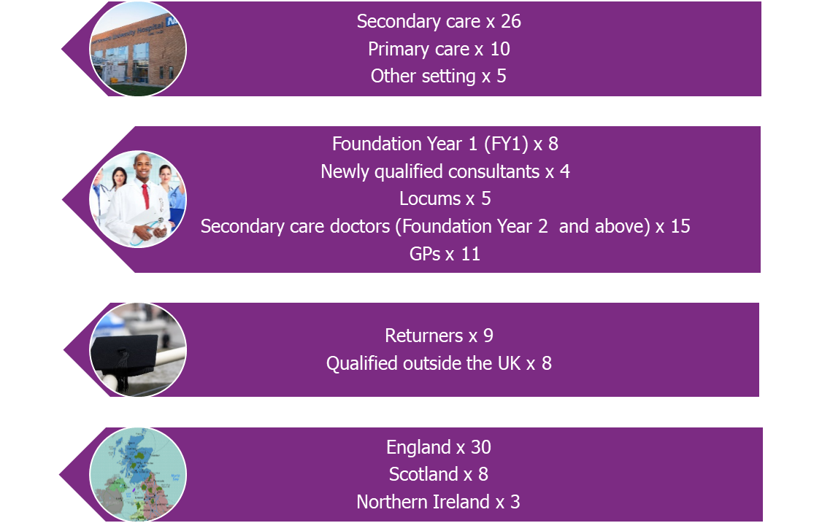

Doctors were given a cash incentive, or an equivalent charitable donation, as a thank you for their participation in the interview and as a goodwill gesture to acknowledge the time taken to participate.

2.3.4 Interviews with stakeholder organisations
In addition to speaking to doctors, nine stakeholders were interviewed from individual hospital trusts/health boards (Directors/Associate Directors of Medical Education, Return to Work Lead), deaneries (Postgraduate/Associate Deans) and national bodies (BMA, Academy of Royal Medical Colleges).

Stakeholders were not offered an incentive for taking part.

2.3.5 Fieldwork process
All interviews were conducted during a period from the 23rd September until 6th December 2019.

The interviews followed a semi-structured guide in order to allow participants to elaborate on and discuss their views and perceptions freely. All interviews were facilitated by Community Research. The interviews were audio recorded and transcribed. The discussion guides used are provided in Appendix 2.

2.3.6 Notes on reading the report
The definition of induction and returners has been taken from the GMC tender document which set out:
- ‘Induction’: the package of meetings/training/information/orientation provided for doctors joining a new hospital/directorate/department.
- ‘Returners’: doctors returning to clinical practice after an absence of three months or more.

Where examples of good practice have been highlighted (in purple text boxes) it is important to recognise that, although they may have been evaluated by others, the GMC has not formally evaluated these examples. They are, therefore, considered good practice from the perspective of the interviewee(s) who outlined them as such.

3. Understanding doctors’ expectations of a safe and effective induction

Section summary
- Doctors’ experience of their most recent induction varied across the sample, with seven doctors of the 41 interviewed not receiving an induction for their most recent role.
- Doctors across the sample identified several common elements to a safe and effective induction. However, for some there was a discrepancy between what they regarded as a safe and effective induction and the induction they received.

3.1 Variability of recent inductions
An induction was considered vital for doctors to be able to effectively function in their new role from the outset. Doctors who had started a new role in a new setting and doctors on training rotations all expected and had received an induction (to varying degrees). However, there was less consistency of experience amongst locum doctors, doctors who had returned to practice or doctors who had changed role within the same setting. In a number of instances these doctors had not received an induction at all, nor did some think that one was necessary.

Figure 1 overleaf is designed to highlight how inductions varied across the sample. It is a simple qualitative assessment of doctors’ most recent experience of induction - it does not take into account their wider experience of inductions. As highlighted in Section 3.2, many of the doctors we interviewed had experienced a number of inductions and could cite both good and bad practice. As shown in Figure 1, many of the doctors had had a mixed experience most recently and could identify how the induction they received could have been improved.

As outlined in Section 4.4, primary care settings were perceived as being well placed to deliver tailored inductions, with several doctors highlighting good examples. However, this was not every doctor’s experience of induction within primary care with a number of GPs in our sample indicating that they had not received an induction when they returned to work or changed their role or setting most recently.

Figure 1 – Qualitative assessment of doctors’ most recent experience of induction in new role
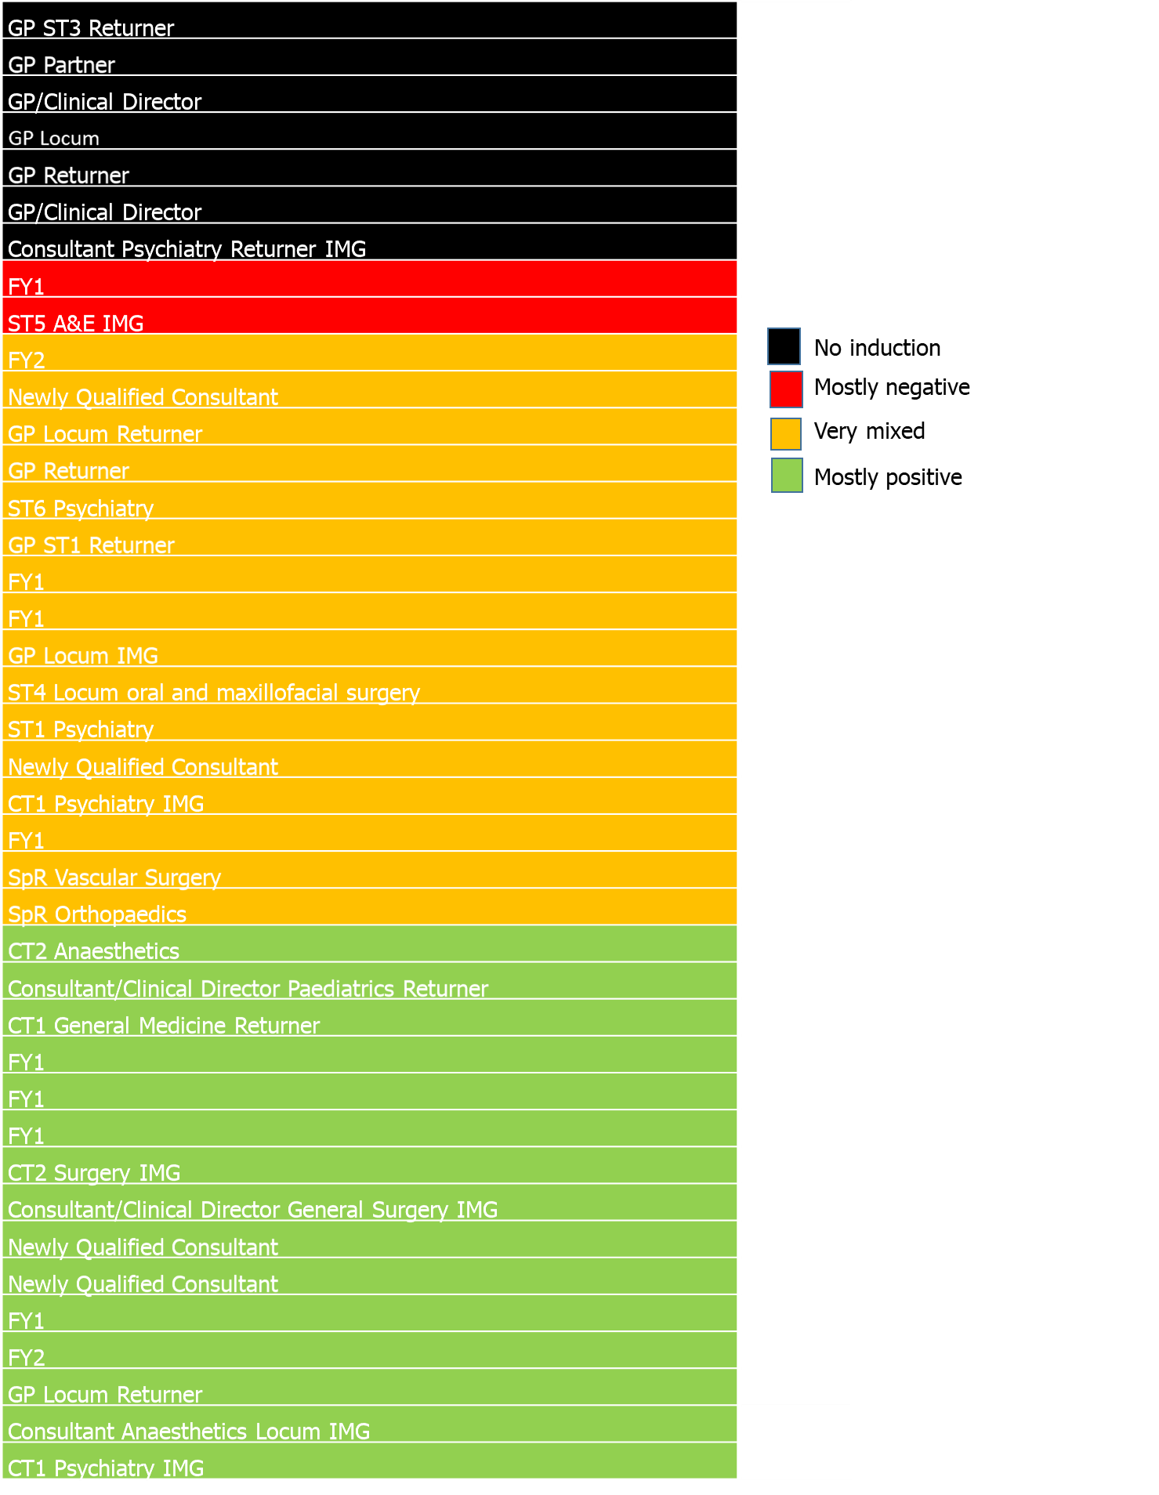

3.2 Past experiences of induction
Although some doctors were positive about their most recent induction, this was often contrasted with previous, more negative experiences of induction. In general, few secondary care doctors had high expectations of induction when starting a new role, with the exception of a consultant starting work at a children’s hospital. This doctor felt that the specialised nature of the work would demand a more thorough induction than they had previously experienced.

“I guess I’d been to enough NHS inductions that I didn’t have very high hopes. I think everyone buys a lot of coffee and they expect to be bored by fire lectures and computer system inductions.” (ST1, GP, Returner, Scotland)

Given their low expectations, doctors moving into primary care were often pleasantly surprised by the induction process.

“I’d say my experiences at both practices were great, inductions I thought were fine, again, kind of being started off gently with a building up to full speed. Hospital inductions were a different story [laughs]. They are very generic; you almost learn by doing things wrong and then someone pointing out that you’re doing it wrong.” (GP, Returner, Locum, England)

3.3 Key elements of a safe and effective induction
Although experiences varied across the sample, doctors expected the following elements to be part of a safe and effective induction.

Table 1 – Elements of a safe and effective induction
Gaining access to places and systems | - Issuing of security passes/passwords  - Enabling access to relevant areas of the hospital/practice  - Logins and passwords for IT systems and specific machines/equipment
A physical orientation of the setting | - Staff facilities (toilets, lockers, parking, staff rooms, study rooms etc)  - Key equipment (from cannulas to crash trolleys)  - Key departments/offices  - Tours of different settings if working across sites
Team introductions | - Immediate colleagues  - Relevant people within the wider setting/wider multi-disciplinary team  - Including management staff
Gaining knowledge of how things work – focus on the day-to-day | - An understanding of relevant HR processes:  - How the rota works; how to request study or annual leave  - How to resolve any issues with pay  - An understanding of how a specific workplace is run:  - Test requests, clinical pathways, referral pathways, discharge processes and any specific hospital/practice policies  - What is the ward routine e.g. foundation trainees wanted to know what time senior colleagues attend  - An understanding of any key equipment used
Familiarisation with common cases/procedures | - An understanding of the types of cases frequently dealt with  - Particularly relevant for doctors in foundation training
Understanding what is expected | - Of them as a doctor (duties and responsibilities)  - Of others (responsibilities of the wider healthcare team, what and how to delegate/escalate)

3.4 Discrepancy between perceptions of a safe and effective induction and reality
As seen in section 3.1, doctors’ experience of their most recent induction varied, some spoke positively of their induction and others held more mixed views. For many doctors there was a discrepancy between what they would regard as a safe and effective induction and the induction they received. This appeared to be particularly evident amongst secondary care doctors, who talked about trusts/health boards focussing on corporate induction and mandatory training, rather than on departmental inductions that doctors relied on to be able to function day-to-day. The discrepancy between doctors’ expectations and reality was also acknowledged by a Postgraduate Associate Dean.

“You go and you do this tick box exercise and most of it’s not relevant to your actual job but you’ve sat through six or seven hours of it, and what you want to know is where your ward is, you want to meet the staff, you want to know the really basic things, where are the staff toilets, is there a changing room, where is the vending machine, where can you go to get a coffee, where is the canteen, where are your secretaries, where does your consultant live, where does his secretary live. These are the important things that you need to know even if they’re never covered in an induction, and they’re the things that allow you to work more efficiently but also feel part of a team….What you need to do is, you need to be with the people on the ward, having a walk round, being taken on a guided tour, being able to ask questions, being told how things work, being given the inside knowledge of it, and being introduced to the people that are going to make a difference.” (Salaried GP, Northern Ireland)

4. Exploring the induction process in depth
Section summary
Doctors agreed that that a safe and effective induction was best delivered at the departmental or GP practice level. Examples of good practice included:
- Sending out key information in advance of the doctors’ start date (organograms etc.)
- Face to face meetings with key staff (including outgoing trainees) and walk arounds to familiarise doctors with the team and local setting.
- E-learning modules (but not too many) relating to the trust/health board or practice’s mandatory training requirements.
- Video links to allow all doctors to participate in induction (who might not be able to attend physically).
- A structured period of shadowing (particularly amongst lower training grades).
- Access to handbooks and intranet (highlighting where to find key information).
- Inclusion of role plays and simulations relating to key aspects or the doctors’ new role.
- Opportunity to gain hands on experience of IT systems.

4.1 Overview
Doctors’ experiences of induction varied across the sample and were often unique to a particular role, individual circumstances and setting. This section looks at induction across primary and secondary care settings as well key elements of the induction process that are common to both, with the intention of highlighting good and poor or unsafe practice. Where relevant, differences between types of doctors are highlighted, however, further detail relating to IMGs, returners, FY1s and newly qualified consultants can be found in Section 5.

4.2 Pre-induction
The extent to which organisations liaised with doctors prior to them commencing their new role or returning to work was inconsistent. In the worst case scenarios, not receiving information in advance, or not receiving sufficiently detailed information, was linked to confusion and frustration. For example, one FY1 doctor had received no information in advance of starting their first rotation (even after asking for it) and had to rely on contemporaries to tell them where to go; another doctor had not been told how to locate the consultant they were reporting to on the first day which had resulted in hospital staff looking for them.

Both doctors and stakeholders believed it was best practice to send out tailored information in advance of a doctor’s induction. The key information doctors called for before starting a new role was:
- Names of key people in the organisation/department.
- Who to direct questions to in advance of starting.
- Map/instructions of where to go on the first day.
- Information about rotas.
- Details of any e-learning modules to be completed (along with associated log-in details).
- Access to appropriate handbooks (print or electronic) to allow doctors to familiarise themselves with setting specific information.
- GPs, in particular, liked to familiarise themselves with referral pathways in advance of starting a new position.

“So what works really well would be finding out about the unit or the department before you even started. When I used to cover my own department induction, you’d email out at least a couple of months ahead of them starting, at least six weeks is the minimum they say but earlier the better, and then inform them that this is your plan for the afternoon.” (Postgraduate Associate Dean)

A number of doctors believed that such introductory information not only fulfilled a practical need, but also an emotional one. They explained how it helped ease the anxiety associated with starting a new role and made them feel valued.

“I think the fact that the college tutor had emailed myself and the other trainees weeks before we started, the email was to my name, it gave me the name of my clinical and my educational supervisor. It was welcoming you to the department, some useful bits of information for you to read beforehand and then also was very approachable in between via email about questions you had, whether it was to do with the rota or job specific. Compared to the ED induction I had last year which was very much you turned up on the day and you were told “these are your passwords, these are your logins, this is a tour of the department, crack on.” (CT2, Anaesthetics, England)

4.3 Induction in secondary care

4.3.1 Corporate induction
Corporate inductions were scheduled at times of key changeover. Doctors (across all grades) reported attending their corporate induction, with several exceptions:
- One contract locum doctor believed that as they were not classed as permanent staff the hospital policy did not require them to attend an induction.
- Several doctors, who had previously returned to practice, had missed the corporate induction because they were ‘out of sync’.
- Several doctors who had started work on a night shift did not have cover arranged and could not attend the full induction.
- Several doctors in rural areas (away from where the main induction took place) had not been able to attend.

“Because I started in February so it wasn’t really during the doctors’ changeover or anything like that. I think I’m classed as a locum or zero hours contract, people like me don’t tend to go for trust induction because we’re not counted as permanent staff" (Locum, Secondary care, England)

The set, mandatory nature of corporate inductions led to several doctors attending ‘unpaid’ when they were not on rota to work.

“And they are also very inflexible. So, if for example you miss said corporate induction, obviously it’s really gutting, but anyway if you miss it, you get constant harassing e-mails saying right you’ve got to come on this date or that date instead. Now, irrespective of what else you might be doing, whether you’re a doctor, and are rota’d that’s your off day, irrespective of your lessons for time, irrespective of anything. It’s just like, well that’s when they are.” (ST4, Returner, England)

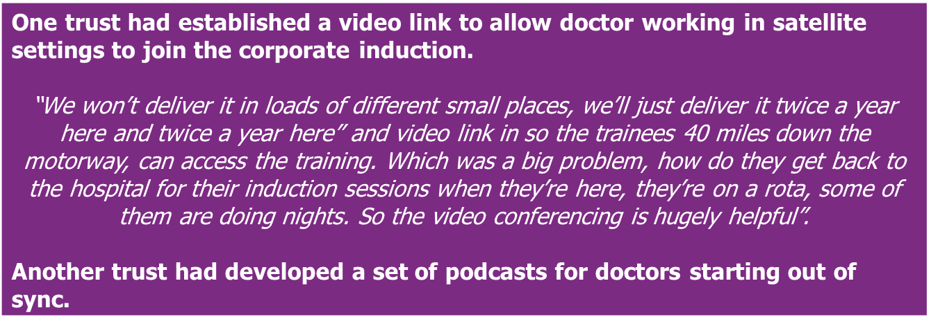

Regardless of the difference in length and content, doctors’ reactions to corporate induction were generally consistent across the sample. Doctors almost universally referred to corporate induction as a ‘tick-box’ exercise that met the needs of the trust rather than addressed the needs of individual doctors. Some doctors questioned how much of the information delivered in a corporate induction they took on board and how much of it was relevant to their day to day role.

“So it felt like a bit of a tick box thing of “we’ve told you this now so, if anything happens, it’s not our problem” sort of thing.” (Specialty trainee, Northern Ireland)

“Because before you start in a hospital, especially if you’re starting in a new hospital, a lot of things that are given to you, thrown at you, during trust induction is not something you will directly keep in mind. So a lot of it just goes above your head, you don’t remember half the things, or even more than half the things, that are said during trust induction, it's like a whole day of a waste of time.” (Locum, Secondary care, England)

When talking about their experience of corporate induction, doctors consistently raised several themes:

- There is value in being welcomed to the trust
Doctors were least critical of the ‘Trust Welcome’ and, when delivered by senior members of the management team, some doctors believed it helped demonstrate to a new cohort of doctors that they were a valued part of the team. They also recognised that members of the senior team were often more experienced and inspiring speakers. Several doctors felt there was scope to make the initial welcome more inspiring by including information on opportunities for career progression within the trust.

“I think we all just thought it was quite nice, like “oh, they can be bothered to come and speak to us for 20 minutes”. You feel quite valued, I think, that they’ve bothered to make some time, especially when it was like eight o’clock in the morning. And they always give kind of, not interesting but you get a feel for where you’re going to be working and things. It’s normally one of the more interesting and better talks.” (CT1, General Medicine, Returner, England)

- Induction to trust IT systems is often generic and ineffective
Some doctors spoke of receiving an IT induction in groups or in a large auditorium. Depending on the format, the length of the induction was reported to last between 2 hours and a full day. Regardless of how familiar doctors already were with the hospital IT system, they spoke of having to sit through the same induction; reflecting the inflexible nature of corporate induction.

“So a lot of our IT systems are regional so people will have used them before. So there is a sense that you have to go through this, everybody kind of tunes out until the coffee break.” (Specialty trainee, Northern Ireland)

“I just think it might be useful if before they are offered the induction, they can either say okay, I’ve worked here before I only need the minimum, my password and just some quick questions. Or, I’ve never worked here in my life, I’ve never used this system, please can you give me a proper session, along with anybody else who is in the same position.” (ST4, Returner, England)

Doctors of all grades questioned the effectiveness of a lecture-style IT induction and, to a lesser extent, an IT presentation delivered in a small group. Rather most preferred to receive a practical (hands-on) induction to IT. Regardless of format, for doctors new to the IT system, it was difficult to gain the necessary information in one session.

“It was very lecture based as opposed to practical. One of the feedbacks I would have put down was there should have been more time for IT induction, getting used to the systems, because that’s the first thing people struggle with when they switch over. A couple of the lecture based things could have been based on the eLearning but I think the IT system should have been a half day at least just to get your hands on.” (FY2, England)

Suggestions to improve the IT induction included:
- Tailoring the induction to the needs of specific groups of doctors (e.g. those who are familiar with the system and those who are not).
- Giving doctors an opportunity to gain hands on experience of the IT system; getting them to practice working through relevant scenarios.
- Ensuring that it is delivered by someone who uses the system as a clinician rather than from the perspective of the IT department.
- Providing IT drop-in sessions or opportunities to attend a further IT induction after doctors had started their role and gained some hands--on experience of the IT systems – so they knew the questions they needed to ask.

An interview with a Medical Director of Education highlighted several issues linked to organising effective IT training in their organisation:
- Lack of space within the hospital to accommodate hand-on IT sessions.
- IT training not taking place on the ‘live’ system, preventing doctors from setting up favourites and shortcuts which would help them in the future.
- Lack of IT staff (due to under-resourcing) to conduct ‘floor walking’ around key start dates and offer direct support to doctors.

- There is a need to streamline the mandatory training elements of corporate induction
Doctors called for the mandatory elements of induction to be streamlined, and for more time and focus to be placed on the all-important departmental induction. Suggestions to streamline the mandatory elements included:
- The use of film to covey key points concisely and effectively.

“When I worked in an ITU trust and, rather than having an hour’s talk on infection control, they had made the hour’s talk into a five minute video that was played and you had to watch. So you watched a five minute video rather than listen to somebody talk for an hour about slides behind them but it meant if you had questions there was nobody to ask the questions to. But I don’t think that was a problem, they had no questions.” (CT2, Anaesthetics, England)

- Move more modules on-line, a suggestion that reflects what is already happening in many trusts. However, at the same time, doctors raised issues relating to the compensation (time and money) that doctors received for completing e-learning modules. (see section 4.5)

“I’ve actually had this conversation with the nursing staff in A&E because they were very keen to make our induction useful. What I would do is, I would try to get as much stuff online in terms of the statutory stuff that we have to do. Like I know that we have to have a fire lecture, there’s certain boxes that you have to tick so I would put that into online modules and then I would have a question and answer session. So you’d check that everyone has done it, that everyone was happy with it and understood it, you could even have a little quiz but I would keep that very brief, like a quarter of the day for the statutory stuff” (ST1, GP, Returner, Scotland)

- A number of doctors and stakeholders believed that the ‘holy grail’ for streamlining the mandatory elements of induction was the creation of a mandatory training passport recognised across trusts. Several doctors and stakeholders explained that there was already work going on in this area, both locally and nationally but that it was not an easy ask (issues relating to content and corporate risk needed to be explored).

“The two trusts have this thing called a Kings Health Partners Passport. Which basically means that if you’ve done your induction at Guys and St Thomas’, Kings or the Maudsley Trust, that the induction that Guys and St Thomas’ have done for you, is of sufficient standard that they can therefore take it as red that you’re okay to work within their trust, and they will cover you. So, you don’t have to keep repeating your mandatory training.” (Newly qualified consultant, England)

- Structured near-peer learning is welcomed as part of the corporate induction
Foundation year doctors welcomed structured learning from peers. They felt that those who had previously completed the grade or the rotation played a vital role in getting a new cohort up to speed; teaching what, otherwise, new doctors would have to learn the hard way. This is echoed in the literature review which highlights examples of structured near-peer learning in both corporate and departmental induction programmes.

Several stakeholders gave examples of how they had used or witnessed structured near-peer learning. For example, using peers to deliver presentations or to design and/or review induction materials.

“Even things like the trust intranet always comes up, so there might be some really useful information which is shared but, if you don’t even know how to navigate and get to that point, those are the bits which I find that the junior doctors do really well when they’re doing their sessions because they’ll literally put their computer on the big screen and show them that this is where this bit is, this is where the antibiotic policy is, this is where if you’re really struggling at night you’ve got all the contact numbers on here. That kind of really practical information that doesn’t always come from the seniors, that could come very easily from the junior doctors as well.” (Postgraduate Associate Dean)

4.3.2 Departmental inductions
Doctors primarily relied on a departmental induction to address their needs for a safe and effective induction; giving them vital information for their day to day role.

“Specific to this job in terms of where the patients come in in the morning for me to see them before their anaesthetic, do they go to the theatre, do I see them on the wards? How do I contact the consultant in the morning whose list I’m on, how do I find out which list I’m on, where’s the coffee room, roughly what time do the lists start, break for lunch, finish in the evening? Just day to day running questions that, after you’ve been there for two weeks, you think you can’t even remember not knowing” (CT2, Anaesthetics, England)

Departmental inductions varied in length between one hour and one week and there were several stories of doctors not receiving a departmental induction at all. Again, it was the variable quality (rather than complete absence) of a departmental induction that appeared to be the most common issue.

The table overleaf sets out examples given by doctors of where departmental induction did and did not deliver against being safe and effective, highlighting the variability of experience.

Table 2 – Variability within departmental inductions
Physical orientation
Shown around the setting and told where key equipment, forms and staff are located  - One doctor gave an example of a unit putting on a ‘scavenger’ hunt as way of helping new doctors familiarise themselves. | Received no orientation  “I had to find the consultant, it took me 5 minutes to even find like who was in charge on that day (ST5, A&E, England, IMG)  “There wasn’t really an induction there because the induction period for that took place at the same time as my psychiatry induction. So I didn’t attend both.” (FY1 England*)
Introduction to the team
Introduced to team members  Unit displayed a picture board of local staff  Pictures of team sent out in advance (organigram)  Unit ensured staff wore name badges during induction  - Doctors reported that it was easier to track down the right person; ask questions of named individuals. | Team not introduced and roles not articulated  “But we had no idea that she existed and that she should be doing all the venflons on our ward, and we spent most of our nights going around doing bloods and venflons which was somebody else’s role, but we had no idea that we should be declining to do that work because nobody told us she existed.” (Salaried GP, Northern Ireland)
Gaining knowledge of how things work – focussing on the day to day
Introduction to key equipment to be used.  - As one senior anaesthetist explained:  “We use anaesthetic machine to deliver anaesthesia, which could be variable degree of complexity and, by the time you’re more senior, you get used to most of the machines you use but there will be slight differences in the set up. So the hospital I work at is actually quite good because I had to have a session to show me all the different types of machines they use and how to use them and some tips about the differences which I think is good because not all the hospitals provide this. I worked in three different places, like I said, this is the first time I have got really a formal introduction to the machines that I have to deal with every day” (Consultant, Anaesthetics, Locum, IMG)) | No explanation of commonly used terminology and abbreviations  “So a lot of things didn’t make sense to me in the beginning. In a day shift, the nurse came up to me and said “changes” and I was like “what does that mean”, and then she just looked at me “I’m asking you for changes”. I told her “it doesn’t make a difference that you are raising your voice because I still don’t know what that means.” (FY1, Scotland)
Familiarisation with common procedures
Use of role plays and practical scenarios  “There was another role play we did, when there’s a deteriorating patient or when there’s a crash call, what you have to do then, and they got all of us to try every single side of it. So one person would find the patient and assess their response, one person would start the chest compressions, one person would manage the airway, one person would manage the crash trolley and would actually deliver the shocks. So everyone got to do everything, those kind of things. That one was quite good because obviously you play a lot of different roles in crash calls” (FY1, England)  Meeting/shadowing peers  “I also think the shadowing was quite helpful as well because, obviously, you need to get used to the environment and how it works on a daily basis, kind of doing small things that are applicable to each ward and how to request certain tests” (FY1, England) | Solely reliant on any information in the trust handbook.  “Paediatrics we got a very big booklet of everything under the sun, which was great but maybe a bit too overwhelming again to get all this information and it was like “everything you need to know is in that booklet so crack on”. Because I started on paediatrics and I was on nights that first week which means that you’ve only got this booklet and the consultant, are you going to wake them up in the middle of the night to ask a question, which could be a really stupid question but you don’t have anyone else around, any other junior doctors to ask” (GP, Locum, Returner, England)
Setting expectations
Encouraging FY1 doctors to ask for help and reassuring them they are not expected to know everything.  “He got us all to write down his number for texting. It was quite a personal thing; he was trying to get at us that “it's fine for you to text me if you’re worried about something”. Obviously, there are other medics you can go to before you get to me but, if you’re really struggling and you’re really lost, don’t hesitate to text someone. So that was quite nice” (FY1, England) | No guidance given about new role and what to expect with the transition to a new role.  “In terms of my job as a consultant, I’m a new consultant so I chatted to people before but I didn’t get a formal induction as to ‘this is consultant life and this is what you need to do, this is what you should be looking out for’ in terms of job planning, appraisals and stuff. I wasn’t told about that officially, just sort of as you go along the job that’s what you got.” (Newly qualified consultant, England)

Shadowing
Shadowing was regarded as an effective way of delivering key aspects of departmental induction. Most FY1 doctors had experienced shadowing, however, it was not limited to doctors in foundation training.

“Because it’s the whole week a shadowing week for me but I had one specific day named as my induction day. But, in fact, the whole induction week was shadowing behind people and doing different stuff as it came.” (Consultant, Locum. England, IMG)

“I definitely felt that the four days we shadowed the previous F1s was very, very useful. Maybe it was a bit short but definitely very useful, especially because I have never trained in that hospital. The hospital I trained in had different systems and different ways of working so this was quite different and it was very helpful to learn during the shadowing period. I believe our next two rotations we don’t actually have these two shadowing days so maybe we go straight into the job; it will be a little more difficult because our first job we had at least four days on the ward and then the next two rotations we don’t” (FY1, Scotland)

Whilst shadowing was appreciated, several FY1s suggested improvements:
- A more structured approach to provide some consistent content within the shadowing period, as it was currently dependent on individuals.
- The need to ensure that an FY1 is available to shadow (given several reports of outgoing FY1s on leave at the time of changeover).

Handbooks/intranet
A number of doctors in training saw value in a Junior Doctors’ Handbook provided by trusts/health boards, which tended to include, for example, common investigations that might be ordered on the ward. There was also a reference made to a specific ‘Asked To See Please’ (ATSP) booklet entitled ‘The ultimate guide to being a confident FY1 out of hours’..

“I usually access it on the computer rather than carrying around with me because I tend to leave things around a lot, I don’t want to lose it. But also it's just easier to ask ‘control F’ and find something by word on the computer rather than going through all the pages in a book. Yes, I’ve used it a good amount of times but I don’t know if other trusts do that, I haven’t talked to anyone about that but I thought that was quite helpful.” (FY1, England)

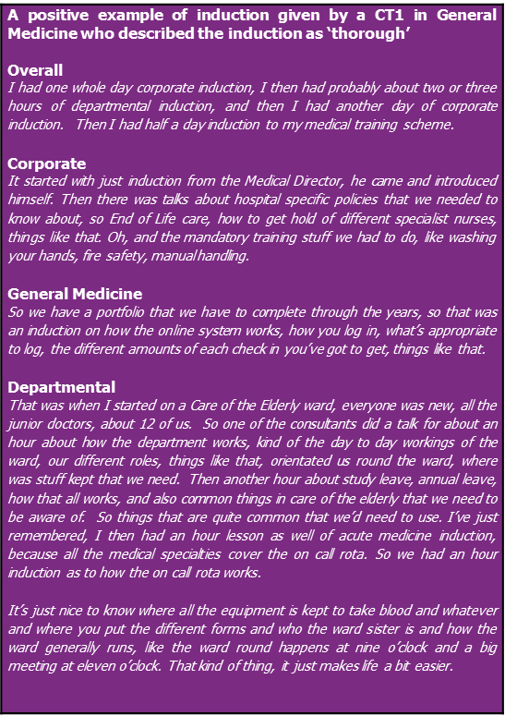

4.4 Primary care inductions
Inductions in general practice often compared favourably to inductions received in secondary care; although this did not mean that inductions in primary care settings were without problems.

Doctors based in primary care all reported receiving an induction as a new starter, but not always when returning after a career break, working as a locum or taking on a new role within the same practice or Clinical Commissioning Group (CCG). The induction was reported to last between half a day and one week (with those in training grades receiving the longest inductions) and included mandatory training; a setting-specific induction and a longer period of shadowing and/or settling in.

What doctors working in primary care wanted from an induction is in line with the information in Table 2, however, the more agile nature of primary care settings meant the elements were often delivered more effectively (and better received) than in secondary care settings. For the following reasons:
- Tailored to individual needs
Doctors working in primary care recognised that there was scope to tailor the content of inductions to a doctor’s individual needs. New starters often had a first meeting with a GP partner to establish any specific learning or development needs the doctor had.

“Then they had days where they would just give you a block of a solid two hours with the computer or discuss anything you needed with the reception staff about how things work or repeat prescriptions, all that kind of stuff. They gave a lot of time for it, it was over two weeks really, and then they just adapted to how you felt.” (Salaried GP, Returner, England)

“They did have, not the time perhaps, because they were busy people, but they were just more, they just be a bit more personalised, and take much more account of me as a person. And as a result, the placement it went well, and I actually finished feeling competent and happy.” (ST4, Returner, England)

- Involved the whole team - a system approach
Doctors often reported spending time with a range of staff members during their induction, including nurse practitioners, district nurses and receptionists.
- Enabling them to gain an in-depth understanding of individuals’ roles and responsibilities across the practice.
- Ensuring that different aspects of the service, referral pathways and IT systems were well understood.

- Time to settle in
In a number of instances, doctors reported having time to settle in, take on the information received during induction, and familiarise themselves with their role. This was thought to be important for the following reasons:
- Salaried GPs explained that it was hard to cope with back to back 10 minute appointments when IT systems and referral pathways were unfamiliar and therefore, if they weren’t offered, some negotiated longer appointment times or blocked out appointments initially.
- GP Partners needed to be confident of their staff, especially trainees, and therefore accepted that some might need an extended settling in period:

“The FY2 that I have currently was a full two weeks, and even now I would still call it an induction period because I’m still having to hold her hand all the time rather than just let her do things she wanted to do, or wishes to do, because I can’t be fully comfortable with her expertise or her comfortableness, as it were, when dealing with situations.” (GP Partner, England)

Shadowing
Doctors in primary care settings also had the opportunity to shadow a colleague for a period of time. This was commonplace across doctors in training roles but more senior GPs were also given the opportunity to sit in during consultations. Shadowing was considered an effective way of imparting some of the elements of a safe and effective induction, for example:
- Doctors benefitted from gaining hands on experience of IT systems (during the consultation of another doctor).

Handbook/intranet
As in secondary care settings, all doctors working in primary care settings, including locum doctors, mentioned that they too enjoyed access to information on the intranet or a handbook that they could use to familiarise themselves with key information: from how to apply for annual leave through to referral pathways.

4.5 E-learning modules
Within many trusts/health boards and general practice settings, e-learning modules play a key role in the induction process, with most doctors having to complete modules prior, or soon after, starting a new role. As mentioned in section 4.3.1, whilst doctors were not averse to e-learning, they did raise several issues:
- Lack of allocated or preserved time: Doctors were concerned that the time needed to compete e-learning modules was not sufficiently acknowledged by their employer. Even when time was allocated for e-learning, it was often not thought to be long enough.
- Lack of recompense: Doctors felt forced to complete e-learning in their own time and highlighted that this added to the pressure they worked under and did little to make them feel valued. Some had asked for recompense but felt that it was given grudgingly (if at all).
- Lack of monitoring: Several doctors, for the reasons highlighted above, reported that they had not completed their e-learning modules and there had been no negative consequences, a situation that was echoed by a stakeholder.

“Well, it was in your own time. Now, the trust have said that they are going to pay staff but I as yet have had no information as to how to claim that back. I think it’s been criticised before in trainee feedback about the amount, because it takes hours to do, so I think that they are planning to pay people for it, or give them time in lieu, but I’d say you’d probably have to go looking for the information as opposed to it being automatically given to you. (Specialty trainee, Northern Ireland)

“One trainee told me that they were trying to complete their mandatory training in their lunch break, between doing a clinic and then going to theatre. And so, each day, they were just grabbing little bits of time to try and get it done. And that can’t be satisfactory or good for anyone.” (Junior Doctors Return to Work Lead, NHS hospital trust)

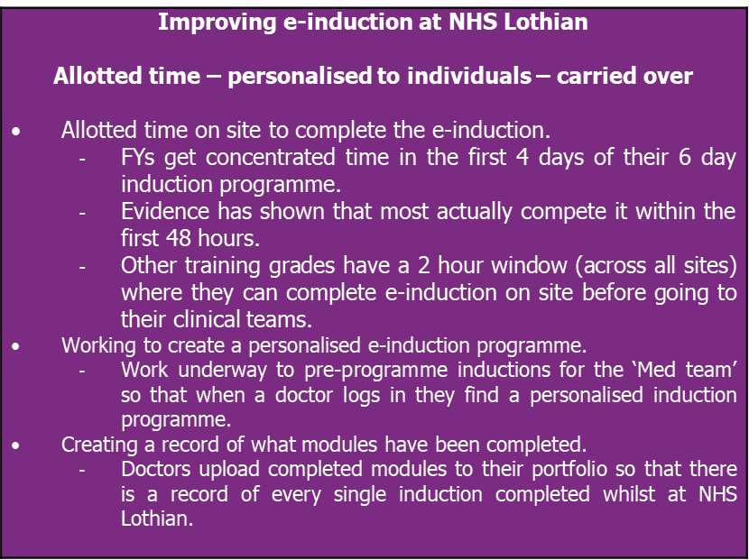

4.6 Mentoring
Few doctors spoke of receiving formal mentoring beyond that offered by appointed clinical and educational supervisors. However, many recognised that a mentoring system would be of benefit (if well implemented) when starting a new role and several had sought out their own informal mentors.

“Yes, I think it definitely would be very useful to have one. There’s a lot of evidence that mentoring does prove useful at any medical grade. Yes, I think that would be certainly very useful. We don’t have formal rules here” (Newly qualified consultant, England)

“Well, actually, I’m trying to develop an informal mentor. One of the consultants at xxx has offered to meet up with me and kind of talk everything through. But he’s extremely busy because he’s the clinical lead there. But that’s the kind of informal mentor I suppose. But I don’t have anything else in the pipeline.” (Newly qualified consultant, England)

Doctors raised several points in relation to establishing an effective mentoring system:
- The process has to be simple.
- Needs to consider logistical challenges (e.g. lack of time) and administrative barriers (e.g. paperwork).
- Needs to consider the most appropriate person – it can be easiest to arrange with those working with the individual directly, but the doctor may be unwilling to share issues with their mentor in this case.
- Include opportunities for near-peer mentoring.

“So there has been talks of mentoring schemes and allocation of mentors but, I know that when I was a foundation doctor and I e-mailed my mentor a couple of times, oh yes, we’ll meet for a coffee, let me know when? We just never managed to do it”. (CT1, Psychiatry, Scotland)

4.7 Workarounds
Some doctors reported that they had to use informal workarounds to supplement the formal induction process. Furthermore, several senior doctors (including consultants and GP partners) suggested that some form of ‘self-induction’ was expected and appropriate and that organisations did not need to ‘spoon feed’ doctors. This form of self-induction appeared to be reliant on understanding the system and having existing networks – so called ‘social capital’ – which could potentially disadvantage doctors new to an area or country.
- Utilising informal networks
A number of doctors (from foundation level through to GP partners and clinical directors) sought information about their role and responsibilities from networks they had established at medical school and/or through the course of their career.

“So we have friends who have done that rotation just before so we tend to ask them how things work. I guess in a way we sort of do our own research and we find out what time things get done and just basically the way that the ward works”. (FY1, Scotland)

“You normally work around it. You learn it as you’re taught it very quickly. People say talk to this person. The nursing staff or the senior colleagues will let you know. You learn how to deal with problems by asking people in the department around you, if there are flaws in the induction. We all do it because we have to. There simply isn’t enough time to do a 5-day induction. …. We are thrown into on-call situations with a bleep, with the trauma bleep, on the first day. Do I think it impacts on patient safety? It can do, but I think we compensate very well. Because we talk to the right people, we’ll text each other, not about patient information, but where is this, what does anyone know this.” (CT2, Surgery, Northern Ireland)

- Relying on junior colleagues/other members of staff
Numerous doctors reported relying heavily on colleagues in the first few weeks, with some concerned that they were adding to the workload of the team they had just joined.
- Newly qualified consultants sought support from doctors in training.
- Foundation Year doctors sought support from the nursing team.

“So I just completed the jobs for the first night in order of the nurse telling me ‘you should do this now and then do this later’.” (FY1, England)

5. Differences by type of doctor

Section summary
Certain groups highlighted additional needs and areas for consideration within their induction:
- Newly qualified consultants wished to receive an induction in managerial issues; felt more consideration should be given to the timing of their induction; advocated for informal networks to be set up.
- Locums recognised that settings were not always able to give them an in-depth induction and were open to workarounds.
- IMGs believed that they would benefit from an enhanced induction that took into account the practical difficulties of getting established in a new country and a completely new work environment.
- Returners requested more information and advice about returning and stressed the need for psychological support within induction.
- FY1s showed particular appreciation for shadowing, near peer approaches, simulations/role plays and ‘survival’ handbooks.

Different types of doctor did not expect a completely different approach to induction but they did highlight additional areas for consideration, support and content that would complement the core content of a safe and effective induction (as outlined in Table 2).

5.1 Newly qualified consultants
Four newly qualified consultants were interviewed during the research. They raised several specific points regarding their inductions:
- Require knowledge and understanding of managerial issues (e.g. complaints handling, how to establish a new clinic, quality improvement methods).

“A consultant's core induction is different to junior doctor I think when you’re a consultant it's more about what are the values of the trust, how do you do a quality improvement project, how do you do root cause analysis or coroner’s, or who’s the trust’s legal department, what legal support do you get, how you address complaints, those kind of things". (Newly Qualified Consultant, England)

“But then there’s all the other stuff around like patient safety meetings and governance and risk meetings, and all these other senior management meetings that as a reg, you don’t really get involved with, but as a consultant you do get involved in.” (Newly qualified consultant, England)

- The timing of an induction - Two of the newly qualified consultants had previously been ‘Acting up’ for a period of 3 months (recommended by NHS Employers’ Gold Guide) but only received an induction when they took on their substantive consultant post.

“You’re acting as a consultant but you’re still a trainee, and so you have to have supervision and stuff which is great, and it’s a really good opportunity. But there is no induction per se. So, there were various things that I needed to take on, like triaging referrals and stuff like that. Which nobody had kind of said this is what you need to do, and you need to get a login so you need to do this training and that, it was just like oh tomorrow you’re the consultant so you can just crack on. It’s only a three-month period you’re allowed to do that for, so maybe they just don’t think that you need an induction, because you’re already within the trust and you’re quite well supported and it’s a short period. It slips people’s minds really.” (Newly qualified consultant, England)

- The benefit of an informal network of consultants (within trust, across specialties) to help consultants settle in and exchange ideas.

“So, it’s a kind of, is there an informal social like we all go to the pub on a Friday, or we all have a coffee on the second Thursday of the month, that kind of thing. Which I think sounds really stupid and soft, but actually probably is one of the most important parts of feeling supported and feeling that you’re able to make changes and make improvements when that’s kind of what part of the role is.” (Newly qualified consultant, England)

"It's hard enough transitioning from being a registrar to a consultant, no amount of training can prepare you for that but, if you’re sent to a brand new department where you don’t know anyone and you’re not sure how things work, not sure what the culture is, it massively amplifies things" (Newly qualified consultant, England)

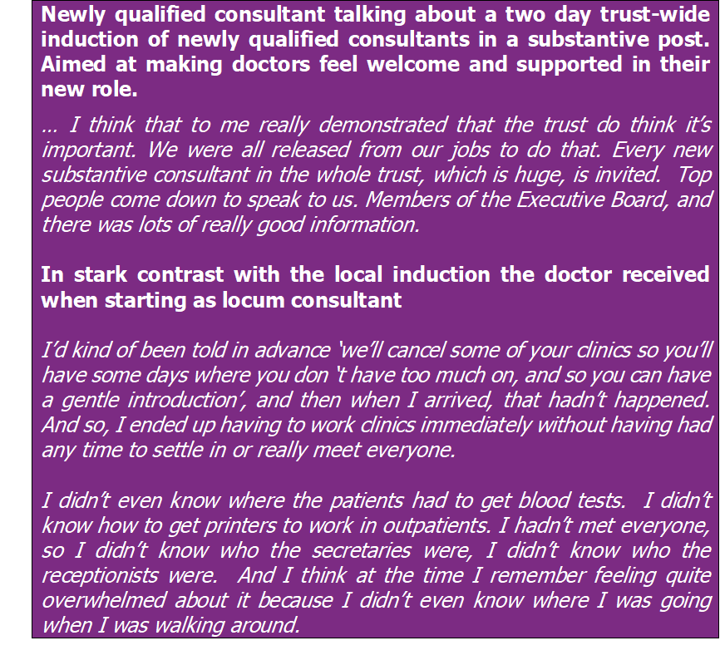

5.2 Locums
GP locums and secondary care locums participated in the research and, in the main, they were employed on a contract rather than via an agency. Their responses reflected those of the broader sample of doctors in that they perceived a safe and effective induction to be grounded in the local setting where there were working day-to-day. Points of difference included:

- One locum doctor suggested that trusts operate different HR policies for locums that do not mandate corporate induction.

- One locum doctor reported that mandatory training elements were completed before starting a role, at the request of a locum agency.

“they also then made me do… they wanted to see evidence of the ALS training, safeguarding, adults and children, and then they made me do an online package as well which covered a whole list of things which I can’t all reel off the top of my head but it covered fire safety” (GP, Locum, England)

- Locums did not always receive (or expect) a very thorough induction due to the pressures that the work setting was under (the reason for them requesting a locum was because they were understaffed).

“So every time you start somewhere new you actually require a mini induction just to get a handle on how they work things and quite often they just expect you to come in, turn the computer on and just fire on, which you can essentially do but a little bit of background knowledge is quite useful.” (Salaried GP, Northern Ireland)

- Locums suggested their own ‘workarounds’ to make up for this.
- One GP had a standard list of questions that they asked in each new setting.
- Other suggestions for workarounds to a full induction included sending out the locum handbook in advance (rather than just receiving it on the day) and getting locums to turn up half an hour before their session to run through any questions.

“So you’re locuming next week, here’s the handbook in a file, come half an hour early, someone will be with you and check are you okay with whatever, the consulting room and the IT, and for questions”. That would be the better way to do things, receiving a locum file or whatever they call it, instructions folder, before you start, yes." (GP, Locum, IMG)

5.3 International Medical Graduates (IMGs)
Eight IMGs took part in the research but they were not necessarily new to the UK. Some of the stories they shared echoed findings set out in the GMC’s recently published ‘Fair to Refer’4 report in that they, and other IMG colleagues, had encountered issues when new to the UK that could potentially have been addressed by an enhanced induction. At least one IMG acknowledged that an enhanced induction could help address future performance issues.

“It would be fair to say people coming from abroad there might be slightly disadvantaged because you come intimidated by the system anyway, you come with your own problems and you struggle. Then you don’t have enough guidance and support and you start performing poorly maybe, not because you don’t know [your clinical skills] but because the priorities are different and the way you communicate things is different” (Consultant, Locum, England, IMG)

Suggestions of what an enhanced induction for IMGs should cover included:

- Assistance with living and financial arrangements. Several IMGs and one stakeholder spoke of how difficult it was to establish new living arrangements on arriving to the UK and the catch-22 that IMG doctors found themselves in: not being able to set up a bank account because they had no proof of address but not being able to rent anywhere because they had no bank account.

“A friend of mine, and I had the same problem as well, we couldn’t get any bank account when we came first to work because we don’t have proof of address, and then you go and rent a house and they don’t give you a house because you don’t have a bank account.” (Consultant, Locum, England, IMG)

“I kept thinking “why is he always here so very late in the day” but it was simple things like he can’t open a bank account until he’s got a contract, the contract hadn’t been sorted, he’d not settled into the bedsit where he was supposed to live so he was sleeping in our junior doctors’ office, and you just think “oh my God, so what happened at induction”, “oh, I didn’t really have an induction, I just got introduced with a few people in and around the wards, shown the computer, given my passwords and there I am doing the ward rounds” and then you wonder why then they leave or don’t settle in.” (Postgraduate Associate Dean)

- More support and understanding of issues with visas. Two doctors gave examples of when they had to take time off work to deal with visa issues. One stakeholder reported that some IMGs missed induction due to visa issues.

- An induction into the culture and language (of the NHS). IMGs acknowledged difficulties in adapting to the culture and language of the NHS and raised several points:
- That in some cultures it was not acceptable for doctors to be criticised by other healthcare professionals which was challenging when working within a multidisciplinary team.
- That they had not anticipated the level of racism amongst patients (and sometimes colleagues) that they felt they were expected to tolerate.
- That they experienced difficulties understanding common phrases and acronyms used in the NHS and the more colloquial phrases used by patients.
- That they experienced difficulties understanding the different training grades/pathways in the UK.
- That they did not always know how best to communicate with colleagues (i.e. the tone of emails)

“I think one of the major issues is doctors have to get used to work with other professionals who would be on the same level as they are, but who are not doctors. They should be able to also handle criticism from other professionals who are not doctors. Where I come from you cannot really criticise a doctor’s work unless you’re a doctor yourself.” (CT1, Psychiatry, IMG)

“I knew nothing when I came here, and no one talked to me about the system saying you can get into training. So, for 2 years was a waste of time, obviously. I wouldn’t say a waste of time, I got a lot of experience. By the third year I had to apply for the next visa, so I couldn’t afford to get into training and pay all the extra visas. I basically shelved my training for 5 years because of the catch-22 situation of visa fees, ignorance and a lack of information.” (ST5, A&E, England, IMG)

- The need to address a lack of some clinical skills. IMGs themselves did not raise issues relating to clinical skills, however, two stakeholders suggested that it was important to recognise that some IMGs might have specific gaps in their clinical skills as a result of having trained outside the UK.

“So, there’s a lovely FY from Italy 4 years ago who came up to me after the skills training at the end of the few days, and just went, ‘I’ve never been taught how to put in a cannula and I’m on nights next week, I don’t know how to do it, I don’t think I can do this’. I don’t think I can be a doctor. And I’m like no…. I’m going to sort you out with the training, they are going to give you one-to-one tomorrow afternoon after your simulation. And that’s what they did. And I got a lovely e-mail back from him at the end of his nightshift saying he’d done really well. That he’d put in 18 cannulas’ on his own.” (Associate Director of Medical Education, NHS Lothian)

The findings from the primary research with doctors are broadly supported by the literature review which identified the following recommendations regarding induction and orientation of IMGs:
- A mandatory national induction programme for overseas doctors complemented by existing local hospital inductions, with content on British culture and language, the NHS, and clinical skills (Jalal et al 2019)
- Induction to be an ongoing learning process for IMGs, with peer support, and monitoring of progress after an induction programme (Kehoe et al. 2016)
- Individual needs assessment prior to an induction (Kehoe et al. 2016)
- Attention to culture, language and how the UK health system operates (Rothwell et al. 2013; Jalal et al 2019).

5.4 Returners
Nine doctors who took part in the study had returned to practice in the last six months and several more recalled earlier career breaks. The majority of these were out of practice for less than a year (as a result of a maternity break, travel or sickness) and returned to the same place of work. They recognised that their needs as returners were driven by their specialty, how long they had been out of practice and the reason for being out of practice.

Some doctors just wanted to know that the practicalities of their return had been sorted (for example, car-parking passes, security badges, passwords and log-ins) whilst others required more emotional and clinical support. The need to tailor induction for returners is supported by Recommendation 28 from the Independent Review of Gross Negligence Manslaughter and Culpable Homicide commissioned by the GMC which sets out that ‘Healthcare service providers should provide induction and support for all doctors returning to clinical practice after a period of significant absence. These doctors should have a return to work meeting and appropriate supervision and support during the induction period tailored to the needs of the individual.’

Several doctors returning to the same work setting highlighted that the setting had changed in their absence, sometimes quite radically (for example organisational mergers, new premises or new IT system). They felt that the importance of induction was sometimes overlooked because colleagues/employers were unaware of quite how much change had occurred.

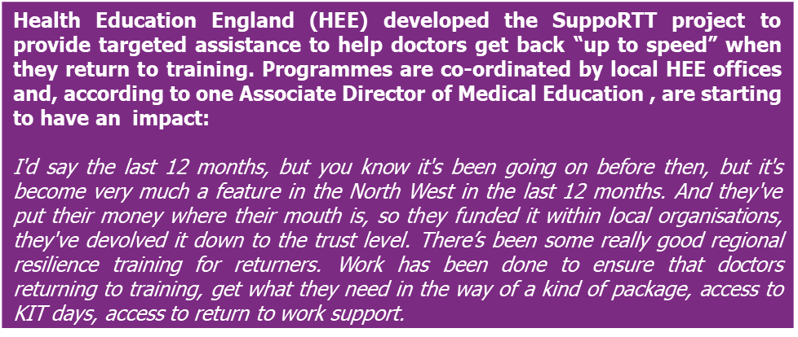
Again, returners believed that the foundations of a safe and effective induction lay in gaining an understanding of the local work setting, however, in addition they raised several points specific to returning to practice that had an impact on induction.
- Lack of consistency in how return to practice is managed. There appeared to be little consistency in terms of how return to practice was managed by employers, and it was often unstructured and informal. In the case of absence due to sickness, the doctor received support from occupational health but, in the main, individual doctors appeared to take responsibility for managing their own return.

“So, this is a generalisation, trainees were going out of programme and coming back in with no structured support. It was all very ad-hoc.” (Junior Doctors Return to Work Lead, NHS hospital trust)

- Importance of ‘keeping in sync’. A number of doctors in training positions made a conscious decision to return in either August or February, to coincide with key induction dates. Doctors returning outside of these times believed they were disadvantaged by being ‘out of sync’ and that individual inductions were harder to arrange (in secondary care).

“What I found really difficult, as soon so you’re out of sync, which naturally most people who have taken maternity leave are, it makes life very, very difficult. You’re starting in a department everybody else has started in already, therefore, you’re basically ignored at lot of the time because that’s not the time when everybody’s rotating and a lot of people don’t even know that you’re new because it’s not change over time.” (GP, Locum, England)

“Some of the barriers that I’ve observed are that the trust inductions are at set times, and if you’re a returner and you return outside of those times, there isn’t a trust induction that you naturally fit into. And so, you often have to do the trust induction in piecemeal parts in that first week or two when you return back, and that isn’t always satisfactory. You can’t always find time to do it……And then there’s often a service level induction which again, is usually delivered at the main change over time. But again, they might not join the service at that time, and so they don’t get the benefit necessarily of the service level induction either. And resolving issues of all the other barriers just by not having access to networks and the hospital Intranet, and the e-mail system. Which I think when you joint at the main change over time, they are generally sorted out in bulk, on mass, with all joining doctors. But when you’re one person joining, at a random time, you’re pretty much left really to try and navigate that yourself. Which can be difficult and frustrating.” (Junior Doctors Return to Work Lead, NHS hospital trust)

- Lack of information and advice about returning. Both returners and a stakeholder focussing on a return to work project highlighted the need to better signpost information and advice for doctors returning to work after a career break. The lack of awareness of Keeping in Touch days, amongst doctors on maternity leave, was given as an example by several doctors.

“There’s no central information point. It’s very hard to get information on the rules and regulations. It’s hard to find contacts. It is all very informal” (ST4, Returner, England)

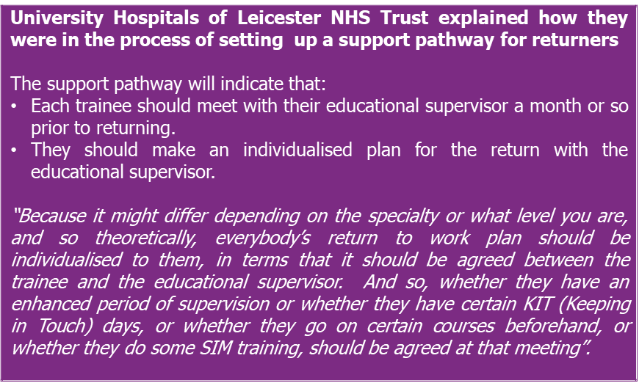

- Using Keeping in Touch (KIT) days as a form of induction. Several doctors who had returned after maternity leave recounted how they had used Keeping in Touch days as a way of proactively managing their return and induction, using them to re-familiarise themselves with the work setting and build confidence about returning.

“I think it seems to be very much on an individual practice/person basis as to how you want to return to maternity leave, I decided that a good way to do it would be to use some Keeping in Touch days to get back into the swing of things. …. If I hadn’t instigated it so early, whether they would have suggested anything I don’t know, because I’m one of those people who likes to be organised and on top of the game and I feel like they probably wouldn’t have said anything until my first day back.” (ST3, GP, England)

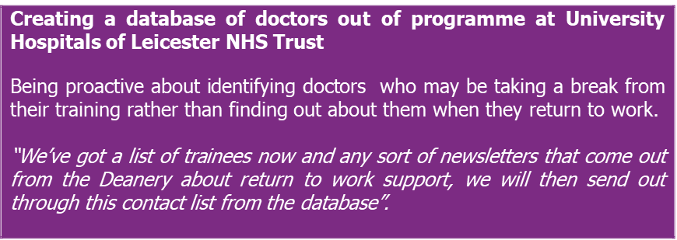

- The need for psychological support. All returners highlighted issues relating to confidence and anxiety (to varying degrees) and felt that an induction for returners needed to address this. These issues seemed to heighten the longer a doctor was out of practice.
- One doctor returning after several years out of practice referred to a sense of shame:

“The vast majority, I would almost say universally, are doctors who were out of practice feel very ashamed. They are deeply ashamed of being out of practice. It can be quite a painful area for them. They don’t have to have left for a bad reason. Because for all sorts of reasons they feel guilty they’ve let their colleagues down, they feel they are not worth it anymore and they can see the NHS is under pressure, they feel guilty they had all the education and they are not using it for what maybe it was originally intended. They feel that if they come back into practice that all their peers will be consultants by now and they are whatever…. And so, I do think for a return to practice, what they do need is the offer of more psychological support. They need to have specific input into things like Imposter syndrome and contemplating if you like, ageism, contemplating the difficulties perhaps of being someone who’s older and who’s working with somebody who’s younger. These things need to be acknowledged and thought about.” (ST4, Returner, England)

- Other doctors who had been out of practice for a relatively short period shared concerns about how they would be perceived by colleagues.

“I didn’t want people to look at me as if I was not competent just because I’d taken a year out. So there was that anxiety around what people’s expectations of me would be.” (CT3, Psychiatry, England, IMG)

- Issues relating to confidence and anxiety were also recognised by a stakeholder working on a returning to practice programme

“But the other thing I’m looking at potentially piloting, is running some, a course of something like art therapy sessions. Where trainees can come and engage with a form of therapy, maybe a monthly, I think we’ve got funding probably to support that. I’m quite interested to see how that benefits trainees who are perhaps struggling with anxiety or, difficulty coping, or confidence on returning to work.” (Junior Doctors Return to Work Lead, NHS hospital trust)

5.5 Foundation Year 1
FY1s reported mixed experiences of inductions and some had struggled with the transition from medical school to regular clinical practice. Key aspects of induction welcomed by FY1s (identified in the literature review and supported by this research) were:
- Shadowing
- Structured ‘near-peer’ approaches
- Realistic simulations (and role plays)
- Helpful ‘survival’ guides, including junior handbooks produced by trusts.

Issues raised by FY1s relating to induction were often common to all doctors, but perhaps felt more acutely amongst those starting their first role because they had less experience and fewer networks to fall back on (Note that the literature review highlights a study by Hamel and Jenner in 2015 that identified high levels of ‘pathological anxiety’ amongst FY1 doctors via an online survey). These high levels of stress, will be explored further in the next section.
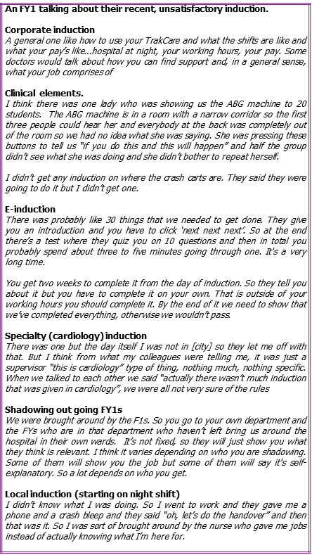

6. Drivers and barriers to delivering a safe and effective induction

Section summary

Figure 2 – Summary of drivers and barriers to a good induction

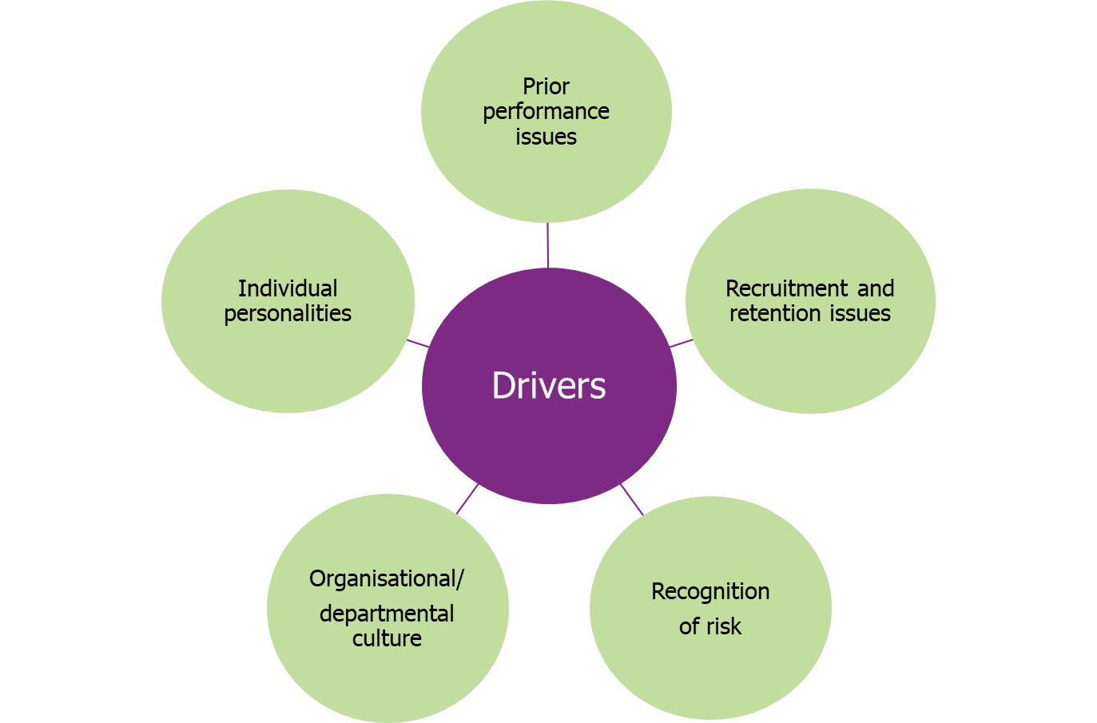

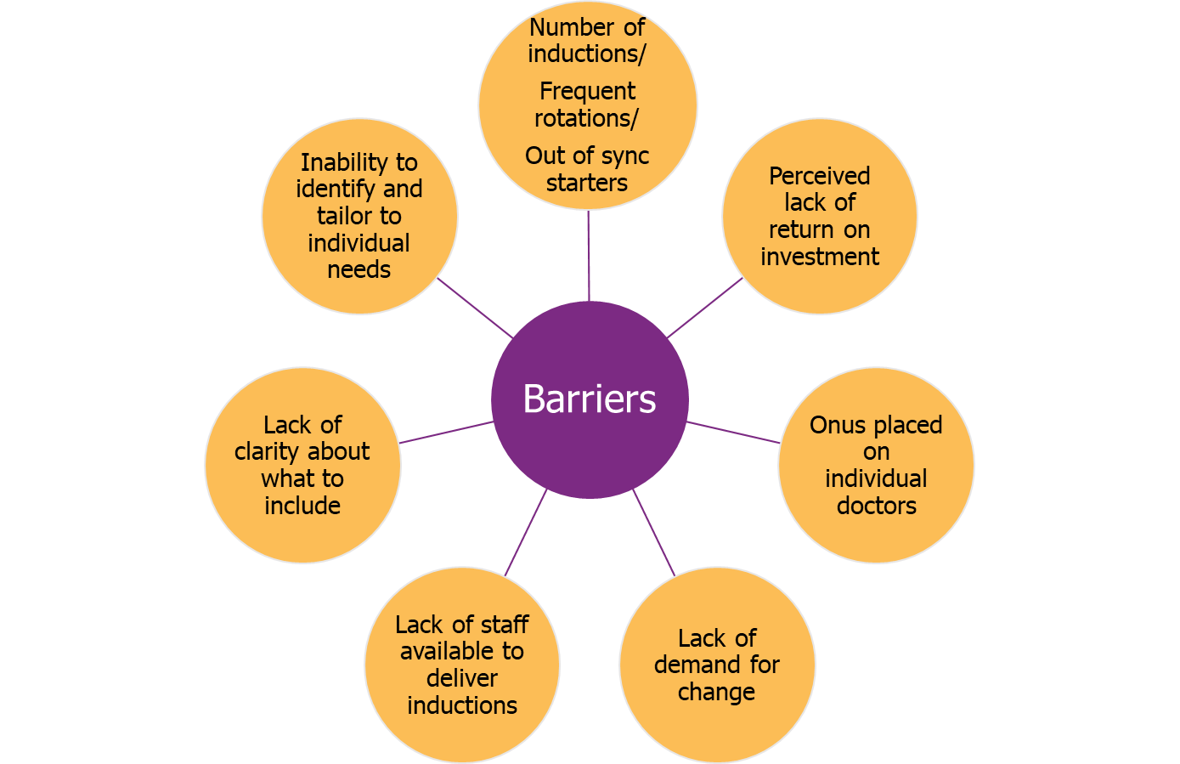

Doctors identified a number of barriers and drivers to delivering a safe and effective induction.

6.1 Drivers to delivering a safe and effective induction
- Prior performance issues. Several doctors and stakeholders acknowledged that organisations were driven to deliver a better induction when they had previously been found lacking by a formal inspection process.

“Sometimes it’s been the trusts which have had recruitment retention issues as well as performance issues from years gone by who have really turned it around.” (Postgraduate Associate Dean)

- A clear understanding of the organisational risks of a poor induction – and who owns the risk. There was suggestion that some organisations were more aware that they owned the risk of a poor induction.
- One stakeholder who had worked on transforming the induction process within their trust explained:

“Because actually, you have the risk because you have the patient. If you’re in the NHS and you’re providing the care, you have the risk, you have the duty of care to your patient and your staff. And therefore, you have the problem.” (Associate Director of Medical Education, NHS Lothian)

- Whereas, one GP partner recognised that they owned both the risk to patient safety and the financial risk of a poor induction.

“But also, it may cost the practice, they’ve not been told about referral pathways or prescribing or review systems and they may be bringing back patients when someone else could do the review. It could be self-referral to psychotherapy rather than having to do a formal referral letter, wasting their time, wasting the secretary’s time, when the patient can just call up and get their appointment directly.” (GP Partner, England)

- Recognition of risks specific to a department/unit. Some doctors believed that some departments/units were more readily associated with risk (to patient and doctor safety) and that they tried to address this risk via induction.

“So A&E does that. They get all the regular hospital trainees that would rotate on one day and then they get all the general practice trainees that rotate a month later and they set aside a day for each of you. So no matter what shift you started on, the first day you were in nine to five with the induction. So, again, no one started on nights or anything like that, you were supervised. We had a nine to five in the A&E department with the supervising consultant and, again, that’s the computer system and anything else in the hospital as well as the fact that it’s A&E which is different. So they took the time. The thing is, if they don’t do that it’s just going to waste more time and be dangerous going forward, so that was a really good induction.” (Salaried GP, Returner, England)

“I think it’s also really important that they get it right, because actually, it’s patient safety, but it’s also doctor safety when you’re working with psychiatry. You’re working with some very acutely mentally unwell patients that can be quite violent. So, you have to make sure that our doctors are inducted in such a way that they are both following the Mental Health Act and acting in accordance with the law. In respect of the patients but also keeping the doctors safe.” (CT1, Psychiatry, Scotland)

- Recruitment and retention issues. Several doctors in rural areas referred to recruitment and retention issues driving changes to the induction of doctors. This was echoed by two Associate/Directors of Medical Education who recognised the role that induction played in creating a lasting impression of their organisations.

“And, again, the [region] is in a situation where it’s trying to recruit, we’ve got shortages in the [region] that you might not have elsewhere and a lot of people don’t necessarily want to be located in the [region] because they’re comfortable where they are, they want to go to [city]. So there are competing drivers and they need to try to overcome that, so they usually put a bit more effort into the induction that they provide.” (CT3, Psychiatry, England, IMG)

“There is a very important part of induction, which is making sure that they feel competent, capable and safe. But the knock-on effect of doing that well is they are more likely to stay for a longer period of time, which can only benefit our workforce.” (Associate Director of Medical Education, North West)

- Organisational/departmental culture. Some doctors believed a safe and effective induction was dependent on the culture of the organisation/department and the value it placed on induction and training. Associate/Directors of Medical Education explained that they issued local guidance but that the delivery of departmental induction remained varied.

- Individual personalities. Several doctors suggested that a safe an effective induction was driven by passionate individuals working at a local level and that more needed to be done to ensure that doctors, with the right aptitude for and interest in induction, were in the right roles.

“The right people doing it. A lot of the time medics and nurses, we tick boxes because we have to do it for appraisals, we have to do it for the GMC appraisals. It’s about people who want to do this sort of thing enabling a pathway to provide that care and mentoring for their colleagues, at a lower level. Rather than it being just something on a CV, truly feeling like, you know what, great if I can make people feel welcome. And that’s what sometimes hard to find the right person.” (CT2, Surgery, Northern Ireland)

6.2 Barriers to delivering a safe and effective induction
- Lack of staff to deliver induction. Some doctors highlighted that there was a lack of available staff to carry out a safe and effective local induction, especially in specialties and locations that were experiencing severe recruitment and retention issues.

“And in one of the areas, the largest, there’s only two substantive consultants, the rest are all locums. And so, when you try to organise induction programme for things like risk assessment and anti-psychotic medication and all this kind of stuff for new doctors that come, you need clinical consultants to do that. Now, the problem is, locums won’t and can’t do it. And so, you’re just running out of people to populate the programme. The Fire service or the HR, they have people, they have people to do that.” (Consultant, Scotland, IMG)

One stakeholder highlighted that staffing issues could be better addressed by early engagement with rota co-ordinators to plan cover and allow doctors time to take part/run the induction.

“I’ve recruited some of my research doctors who are out of programme to man the wards and the clinics on the afternoon of the induction, so they would have a protected time when the induction can happen” (Postgraduate Associate Dean)

- Frequent rotations and increasing number of ‘out of sync’ starters. Several doctors and stakeholders believed that the frequent rotation of doctors in training and the increasing numbers of locally employed doctors starting ‘ad hoc’ resulted in organisations and departments needing to deliver more inductions than they had in the past.

“So that we actually have doctors at all different levels starting on all different days, times of the year. We have some set days, there are a bulk of specialist trainees who will start the first Wednesday in August, and the first Wednesday in February. However, not all, not all specialty schools rotate their specialties in August some do in September and March. If we include locally employed doctors and that will include International Medical Graduates, we have doctors who can start work at any time. So major pressure is delivering a high quality induction that meets the needs of a new starting doctor within a day or two of them starting within the trust. It's almost impossible to deliver that consistently as things stand at the moment in my view.” (Associate Director of Medical Education in the North West)

“At the end of the year when you finally know how to do everything, you forget what it’s like. Everyone has eventually figured it all out and there is not the incentive to do it for the next person because you are leaving” (Specialty trainee, Orthopaedics, England)

- Perception that induction offers a ‘poor return’ on investment, especially in the short term. There was a perception amongst some doctors that staff were becoming jaded by induction - as they did not reap the benefits of their investment in induction:
- Doctors who give up their time to deliver induction get little recognition and an increased workload.
- Doctors in training grades move on frequently so permanent staff within a department have to continually repeat the induction process.

This was an issue that also affected returners, who naturally required more from the induction process.

“And it all depends on whether they see, to an extent, the value of that person to their department long-term. And that’s one of the problems in that, perhaps if you want to induct someone back, but you don’t think they are going to go off and get a training position elsewhere, but you put in quite a lot of work into that person. Where’s the impetus to do so? The people I’m talking about who for example, have had quite long-term induction programmes. They were always very clear that geographically they were happy for them to stay in that department, and so the department can see their value.” (ST4, Returner, England)

- IT systems do not always provide the information needed to tailor inductions. One stakeholder highlighted how IT systems in Human Resources did not always provide granular details of the medical workforce, making it difficult to provide more individualised elements of induction and orientation. For example, a trust would not necessary be able to identify the educational backgrounds of locally employed doctors or identify doctors who are out of programme and will need an induction on their return.

“Some people have really good systems to track who their staff are and what denomination they are, if you like. But some don’t.” (Director of Medical Education, North West England)

- Lack of clarity around mandatory elements. One stakeholder reported that the lack of clarity around what mandatory elements should be included within a trust/health board induction made it difficult to say ‘no’ if and when others in the trust wished to add more content to the induction – this could lead to overload within the corporate induction.

“Whenever you have a critical incident in an organisation, yes, it will go through a process of learning and investigation. That is only right, and they should always do that. What you often see is a recommendation at the end of that that a certain type of training should be provided, and it might need to be included as a part of induction. Which you kind of think superficially the logic of that seems reasonable. But it’s not necessarily an evidence-based solution to resolving it. And I come back to again, without some kind of mandate from the higher regulator saying what fundamentally is required, it’s hard to give an absolute push back on that. Because there’s too many different stakeholders in that decision making.” (Director of Medical Education, North West England)

- Expectations within the profession. Some doctors suggested that the profession demanded them to be competent and that there was an expectation that they would find out what they needed to know (rather than have to rely on induction).

“I think doctors are highly trained people, they’re highly capable people, the mere fact that they’ve gone through the Med School, the mere fact that they’ve been selected for a few places after A level results, they’re capable. Why not make them… there is a bit of this spoon-feeding isn’t always a good thing either, you still need to give these highly capable individuals to source their own needs, learn as it were. As long as they’re not harming the patient.” (GP Partner, England)

However, not all doctors believed that the onus for a safe and effective induction should be placed on individual doctors.

“When something goes badly wrong, like in the Bawa-Garba situation, it was just a whole load of things going wrong, then I feel it’s a bit unfair to place all the blame on the doctor to have said “oh well, they should have ensured that they knew x, y and z, or that they’d covered x, y and z” because, in practice, it’s quite hard to always do that.” (GP, Locum, England)

- Reticence amongst doctors to demand change. Several doctors indicated that they would not be inclined to ask for training and information during induction if they were not offered it. They believed that such demands might affect their professional standing.

“To be honest, if I didn’t get that training, I probably wouldn’t have asked for it because the expectation, what am I, I’m somebody who’s dealing with machinery, the same machines. That’s my day to day job for the last eight years. So, if I can’t deal with this, there’s probably going to be big questions. So I would probably have just got on with it and used it.” (Locum, Secondary Care, England)

More than that, several doctors in training spoke of their reluctance to give accurate feedback in post-induction evaluation forms. Whilst, the feedback was anonymous, they felt that they might be identified and that providing negative feedback could be detrimental to their position. One doctor suggested that feedback should be sought once new doctors were more established in their new role in order to encourage honest feedback.

6.3 Grounding drivers and barriers in behavioural insight
As shown in Figure 3, the drivers and barriers can be grouped using the prism of the Individual, Social and Material (ISM) behavioural insight tool. The three contexts of I, S and M can be understood as follows:
- The individual context - includes the factors held by the individual that affect the choices and the behaviours he or she undertakes. These include an individual's values, attitudes and skills, as well as the calculations he/she makes before acting, including personal evaluations of costs and benefits.
- The social context - includes the factors that exist beyond the individual in the social realm, yet shape his or her behaviours. These influences include understandings that are shared amongst groups, such as social norms and the meanings attached to particular activities, as well as people's networks and relationships, and the institutions that influence how groups of individuals behave.
- The material context - includes the factors that are 'out there' in the environment and wider world, which both constrain and shape behaviour. These influences include existing 'hard' infrastructures, technologies and regulations, as well as other 'softer' influences such as time and the schedules of everyday life.

This helps identify the sphere in which actions need to be taken to help dismantle some of the barriers or leverage the drivers in order to facilitate good induction.

Figure 3 – Drivers and barriers to a good induction by influencing factors

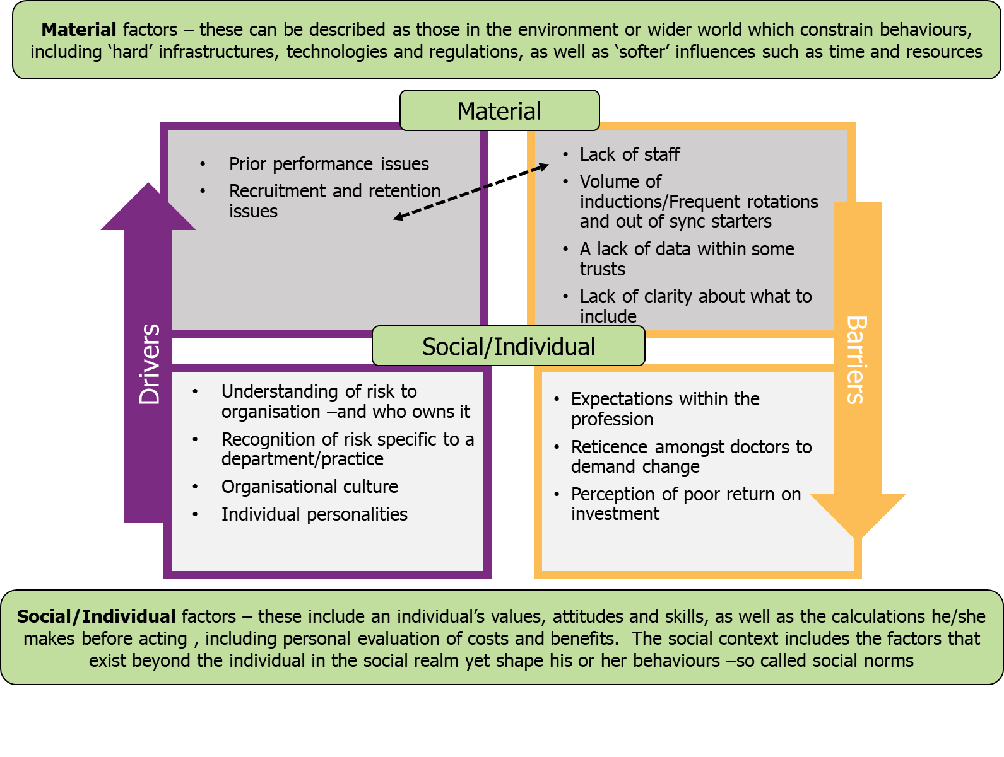6.4 Positive examples of induction
Interviews with stakeholders highlighted that there is already work underway in some trusts/health boards to improve the effectiveness of the induction process for doctors.

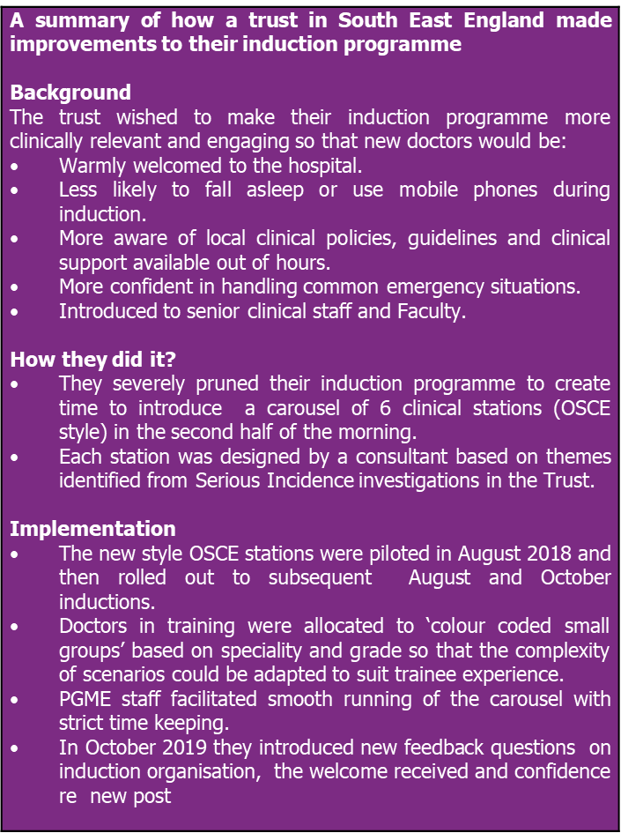

More information on this case study can be found in Appendix 4.
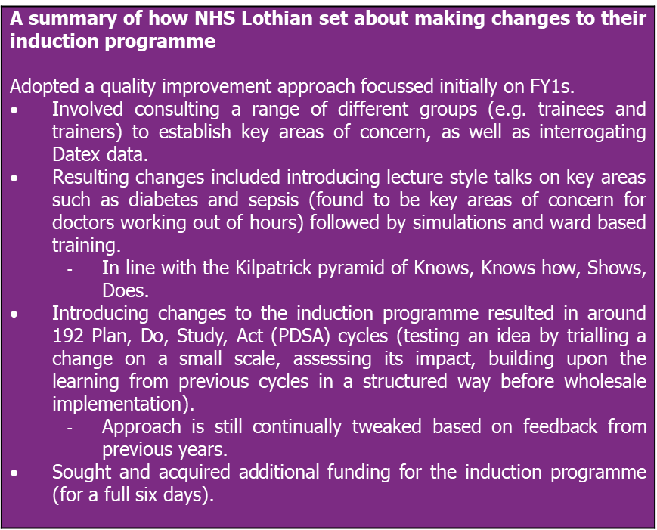

7. Impact of a poor induction

Section summary
- Many doctors believed a poor induction resulted in:
- Increased levels of stress and anxiety.
- Organisational inefficiencies.
- A sense that that the profession was undervalued.
- A number of doctors also suggested that a poor induction could impact directly or indirectly on patient safety.

Most doctors were very clear about the impacts of poor induction on individual doctors, the profession, the organisation and the patient.

7.1 Impact on the doctor
- Doctors believed that a poor induction impacted individual doctors in a number of ways:
- Increased stress and anxiety because doctors felt unprepared for the role).
- This was felt across all doctors, but acutely so amongst FY1s who were starting their first roles.
- Although, one stakeholder highlighted that there were other transitions that were equally difficult and less well supported.

“There are key transition points that we know people find really, really difficult. We’ve already mentioned return to work. So that’s one really tough transition and that doesn’t matter whether you’re foundation, core training, higher specialist training, consultant, whatever. But there’s also transitions like moving from a first on-call rota to a registrar or a second on-call rota where you may now be on-call for different sites. Moving up to consultant level, there are lots of transitions which are really, really stressful and I think sometimes that failure to recognise that”. (Associate Medical Director, North West)

- Caused embarrassment for doctors as they had to (continually) ask colleagues for help, which further exacerbated anxiety.
- Made doctors feel undervalued, sometimes to the extent that they questioned their choice of profession.

“So, the personal effects are that you are a lot more stressed if you don’t actually feel prepared for running an on-call, and essentially as a registrar or as the consultant, you’re in charge of it, you’re running the whole lot. And also, there’s a degree of embarrassment. Because often the registrars often rotate in a different time period to the junior doctors, which is a good thing. But you’re often having to turn to them and say so, could this patient go to the medical assessment unit? What do you guys normally do with these patients. Then you look like an idiot. You know what you need to do medically, but you’re just not quite sure what the trust policy is on PEs for example. Whether they can be given an injection and go home and come back tomorrow or, whether actually in this trust they all get admitted. So that’s on the personal level, there’s the stress and slight embarrassment.” (Newly qualified consultant, England)

How the stress and anxiety experienced by individual doctors impacts on patient experience and issues around recruitment, retention and absenteeism within the medical profession is well documented in the ‘Caring for Doctors Caring for Patients’ report5 commissioned by the GMC. The report highlights that:
- Over a third of doctors working in secondary care indicated that they’d been unwell as a result of work-related stress in the previous year (37% of doctors in the 2018 NHS Staff Survey in England; 36% of doctors in the 2015 Health and Social Care Northern Ireland (HSCNI) Staff Survey; and 34% of doctors in the NHS Wales Staff Survey 2018).
- Just under half of doctors working in hospitals and other secondary care organisations in England are considering leaving the organisations in which they work (47%, 2018 NHS Staff Survey in England).

7.2 Impact on the patient
- Doctors readily recognised that a poor induction could lead to a poor patient experience. For example:
- Several doctors reported making patients wait as they worked out how to request diagnostic tests, carry out discharges, make referrals etc
- They believed this increased stress and anxiety for the patient as they waited and/or got moved (incorrectly) around the system.
- They were concerned that this resulted in patients questioning the ability of doctors. One GP felt this was very detrimental to establishing an ongoing relationship with the patient.

“I think it probably delays things for them. I guess people do things wrong, say it’s a request for a scan but they didn’t realise that they had to go down and discuss it, so maybe that doesn’t get picked up until the next day and then the patient’s had to stay an extra day in hospital where they didn’t have to. I think as well, it’s hard to really focus on the patient when your bleep’s going off, you don’t know how to answer it or you don’t know where the phone is. Even simple things like if you’re walking through a ward and a patient says, “can I go to the toilet” or “can I have a drink”, you don’t even know where to direct them to if you’ve never worked there before. I do think it has an impact for the first few weeks anyway, I don’t think it should take that long for people to settle in but, unfortunately, I think it does.” (CT2, Psychiatry, England)

“Even if you just don’t know where to direct the patient to ask for something, or you send them back to reception desk because you think they’ll know, it just looks poor and the patient gets a bit fed up of being pushed from pillar to post.” (GP, locum, Returner, England)

- A number of doctors explained that a poor induction could be directly and indirectly linked to patient safety.
- Direct: Several doctors questioned the safe practice of doctors in training who were unfamiliar/uncomfortable with escalation procedures; others identified issues with not being informed where the crash cart was kept or how to respond to a crash call.

“Certainly, if it was a crash cart situation then the outcome’s going to be a lot better if everything happens quickly and smoothly than if you’ve got someone panicking thinking “where was it, where was it, oh, I can’t get to that room”, just being uncertain about it. There’s always going to be an element of that but, if it’s because actually no one ever showed them and they kept meaning to get round to asking or something then, yes.” (GP, Locum, Returner, England)

“I was talking before of me seeing all the trainees who then run into difficulty afterwards, some of the bits could all be avoided, and that’s the worst bit, isn’t it, when you see things further down the chain and you think “oh God, this shouldn’t happen”. I’ve had things like people not being ALS, who then cardiac arrests happened and things have gone badly, and then you’ve tracked back and nobody’s picked up that person didn’t have advanced life support training.” (Postgraduate Associate Dean)

- Indirect: Some doctors recognised that the stress and increased pressure caused by lack of induction resulted in doctors not functioning at their best - which could lead to mistakes.

One stakeholder referenced the report of Mid-staffs and Morecombe Bay, and several doctors spoke of Black Wednesday and Bawa-Garba.

“So, if you think about some of the national reports into incidents like Mid-Staffs, or Morecambe Bay…..They talk about what the provision for the frontline tired overworked medical staff is, part of that is about appropriate supervision. But linked to that is their initial orientation as to how you do the work here.” (Director of Medical Education, North West England)

7.3 Impact on the organisation
- Doctors frequently cited that a poor induction created organisational inefficiency.
- Doctors explained that everything took longer as they had to work out how to do things as they went go along.
- For example, GPs sometimes left the consultation to seek answers which impacted on the time a consultation took.
- Some doctors reported that they unnecessarily referred or kept patients in hospital longer than they needed to because they were unaware of appropriate clinical pathways.
- Doctors reported that they disturbed their colleagues with questions and, therefore, affected the efficiency of others in the team.

“It just meant I was a lot slower on the job in A&E. I was having to call over nursing colleagues, other doctors, for help saying, “how do you do this?”. People have been mostly very helpful but it’s also frustrating, in an A&E environment you could be spending five or 10 minutes looking for something and everyone’s running around very, very busy. It definitely made me slower on the job than otherwise.” (FY1, England)

“So I guess, on a trust level, I think the impact is that sometimes you play it safe and you admit people that maybe the trust has a pathway that allows them not to be admitted, but you don’t know about that pathway so you think well I’m not going to just let this patient go home and fall through the gap.” (Newly qualified consultant, England)

- Some doctors believed that a negative impression at induction impacted on staff morale and exacerbated recruitment and retention issues for an organisation.
- Leading several doctors to suggest that creating a good impression with doctors in training might make them more likely to stay with an organisation as consultants.

“So I think inductions are really important. They’re a gateway to understanding how an organisation works, who is involved in the organisation and where the points of contact lead to. So, from that point, they are definitely important and they kind of begin to define the experience you’re going to have within the organisation.” (CT3, Psychiatry, England, IMG)

Finally, one stakeholder highlighted the impact of stress and anxiety on a doctors’ health resulted in increased absenteeism for the organisation.

7.4 Impact on the profession
- There was concern that a poor induction could have a negative impact on the profession as a whole.
- It demonstrated that doctors were not valued and increased an individual’s stress levels which may cause some doctors to question their decision to practice medicine.

“I think, if you show that you value people, as part of your induction you are valued as a person and that we want to help develop you as a person, then I think that will certainly help boost numbers probably for the medical profession, and we’re not just being seen as “oh yes, they’ll just crack on, we just need to fill these empty slots.” (Newly qualified Consultant)

8. Conclusions
There is clear consensus in terms of what doctors would like from their induction which applies across the board i.e. that their induction is:
- Tailored to their individual circumstances, their specific needs and level of expertise.
- Timely – that the physical induction is provided at the right time for them (with some information ideally provided in advance of starting).
- Focussed – that is focussed on what they need to do the job and is expertly designed by people who understand their role (i.e. by both senior colleagues and by those who are currently doing the role or have done so recently).
- Engaging – provides new information in an engaging, interactive way rather than duplicating.
- Welcoming & inspiring – that it sets the tone for their future career and they understand the culture and ethos of the organisation and where they fit within it.
- Evolving – that it isn’t static but that the content changes to ensure that it is up-to-date and responsive to feedback.

However, this is not always what doctors get. From our research the quality of induction is variable and patchy within and across settings. Too often positive interventions are down to individuals putting in extra effort outside of their usual working hours because they are convinced of its importance rather than due a more systemic approach. The induction process is often a missed opportunity to create and foster a positive working relationship. Instead of feeling valued and part of high functioning team, instead new starters and returners can "feel like a tiny cog in a big machine - they are just slotted in to make the machine work." (Junior Doctors Return to Work Lead, NHS hospital trust)

There are numerous barriers to the provision of a safe (and engaging) induction as outlined in Section 6 of this report. These can be grouped in the following way:
- Individual and social factors - These include an individual's values, attitudes and skills, as well as the calculations they makes before acting, including personal evaluations of costs and benefits. The social context includes the factors that exist beyond the individual in the social realm, yet shape their behaviours. These influences include understandings that are shared amongst groups, such as social norms and the meanings attached to particular activities, as well as people's networks and relationships, and the institutions that influence how groups of individuals behave. Clearly individual attitudes of those responsible for induction and the wider social norms associated with induction have a bearing on how induction is delivered and received. There are pervasive low expectations regarding induction. Cultural factors appear to be pertinent - a perceived ‘lack of return’ on investment in the short term and the belief that doctors should be more responsible for their own induction appear to be significant barriers to the provision of more comprehensive inductions.
- Material factors - These can be described as those in the environment or wider world which constrain behaviours, in including 'hard' infrastructures, technologies and regulations, as well as other 'softer' influences such as time and resources. In this context, material barriers to a safe induction can be a lack of time or a lack of staff to plan and deliver inductions. Regulations per se aren’t a barrier to an engaging induction but the interpretation and the way that they are adhered to can be i.e. delivering mandatory training in an inaccessible or unengaging way.

Behavioural theory shows that people are disproportionately more motivated by costs and benefits that take effect immediately than those delivered later. This is often called ‘present bias’, and is explained by the fact that the present is tangible but the future is abstract and hypothetical. This means that people are likely to feel that the short term cost of induction provision outweigh the longer term gains. Behavioural theory also shows that seemingly irrelevant details that make a task more challenging or effortful (deemed ‘friction costs’) can make the difference between doing something and putting it off – sometimes indefinitely.

This means that sharing good practice relating to induction is important. Examples of good practice will need to demonstrate how to implement inductions in a way which isn’t too onerous as well as clearly identify the tangible impact of getting induction right. Given that there appear to be some strong examples of work in this area (identified as case studies in this report), there appears to be an opportunity to do this well. There also appear to be some ‘quick wins’ that are possible to implement to improve the effectiveness of inductions, for example using clinicians to deliver (part of) IT inductions and sending out pictures/organograms of the team in advance.

The literature review concluded that there was a paucity of research about the impact and effectiveness of doctors’ inductions and their influence on patient safety and doctors’ performance. However, our research demonstrates that many of the doctors interviewed had experienced at least one poor induction. This was not a quantitative study and we cannot extrapolate from the findings to make any firm conclusions about the wider population of doctors as a whole. However, the consistency of the qualitative findings, coupled with the stakeholder interviews who had a broader experience base than the individuals doctors, suggest that there are issues to be addressed.

There was a broad consensus amongst our sample that a poor induction can be damaging to a doctor’s mental health and adversely affects organisational performance, efficiency and the reputation of the profession as a whole. This is important as it is in the context of a profession that is under pressure, with concerns about the wellbeing of doctors being well documented5 . Addressing the shortfalls in inductions could be one partial solution to this wider problem.

Furthermore, a lack of a good induction is perceived to be a contributing factor to poor patient experience and, potentially, patient safety. As without a safe and effective induction doctors can feel stressed, undervalued and ‘out of their depth’, resulting in delays in treatment and possible clinical errors.

Finally, since completing this research the Covid-19 pandemic has seen many doctors return to practice, take up different roles and/or move departments – the value of a good induction has never been so clearly in the spotlight.

9. Appendices

9.1 Appendix 1 – Sample breakdown and notes on reading the report

Quotas | Number recruited
Total | 41
Care setting
Primary care, including:  - A mix of GP Partners & others  - Some in rural practices | 10
Acute care, recruit a mix of specialties, including:  - Surgery and anaesthesia  - A&E | 26  7  3
Other setting (e.g. community care, mental health trust) | 5
Country (NB must include a spread within each country)
England | 30
Scotland | 8
Northern Ireland | 3
Type of setting
District General Hospital | 10
University/Teaching Hospital | 16
Other | 5
Career stage/type
Trainees (FY1) | 8
Newly qualified consultants | 4
Locums (mix of agency locum & those with a regular contract)  - Secondary care (may also hold a regular post)  - GP | 5  2  3
Newly appointed to management role (i.e. Clinical Director, Medical Director)  - Primary care (GP)  - Secondary care | 2
Other secondary care doctors new to post (recruit a range of other grades from FY2 upwards) | 15
GPs (who do not fall into other categories) | 7
Career break
Returnees from planned leave of 3 months or more (i.e. maternity/paternity/voluntary break) | 6
Other returnees from unplanned leave of 3 months or more (i.e. sickness, family issues, F2P suspension) | 3
Gender
Male | 17
Female | 24
Other
BAME | 9
Qualified inside EU (not UK) | 3
Qualified outside EU | 5

There are a number of caveats to bear in mind when considering the research findings.

It is worth noting that the doctors who participated in this research ‘opted in’ to the process and actively responded to communication about the research saying that they were willing to participate. It could be that those who opted into the process are different in some way (in terms of their experience of induction) than the wider sample of doctors eligible to participate.

It is also important to note that qualitative research is not intended to be statistically reliable and, as such, does not permit conclusions to be drawn about the extent to which something is true for the wider population.

Throughout the report, quotes have been included to illustrate particular viewpoints. It is important to remember that the views expressed do not always represent the views of all doctors who participated. In general, however, quotes have been included to illustrate where there was particular strength of feeling about a topic.

9.2 Appendix 2 – Research instruments

9.3 Appendix 3 – Literature review

9.4 Appendix 4 - Poster DEMEC

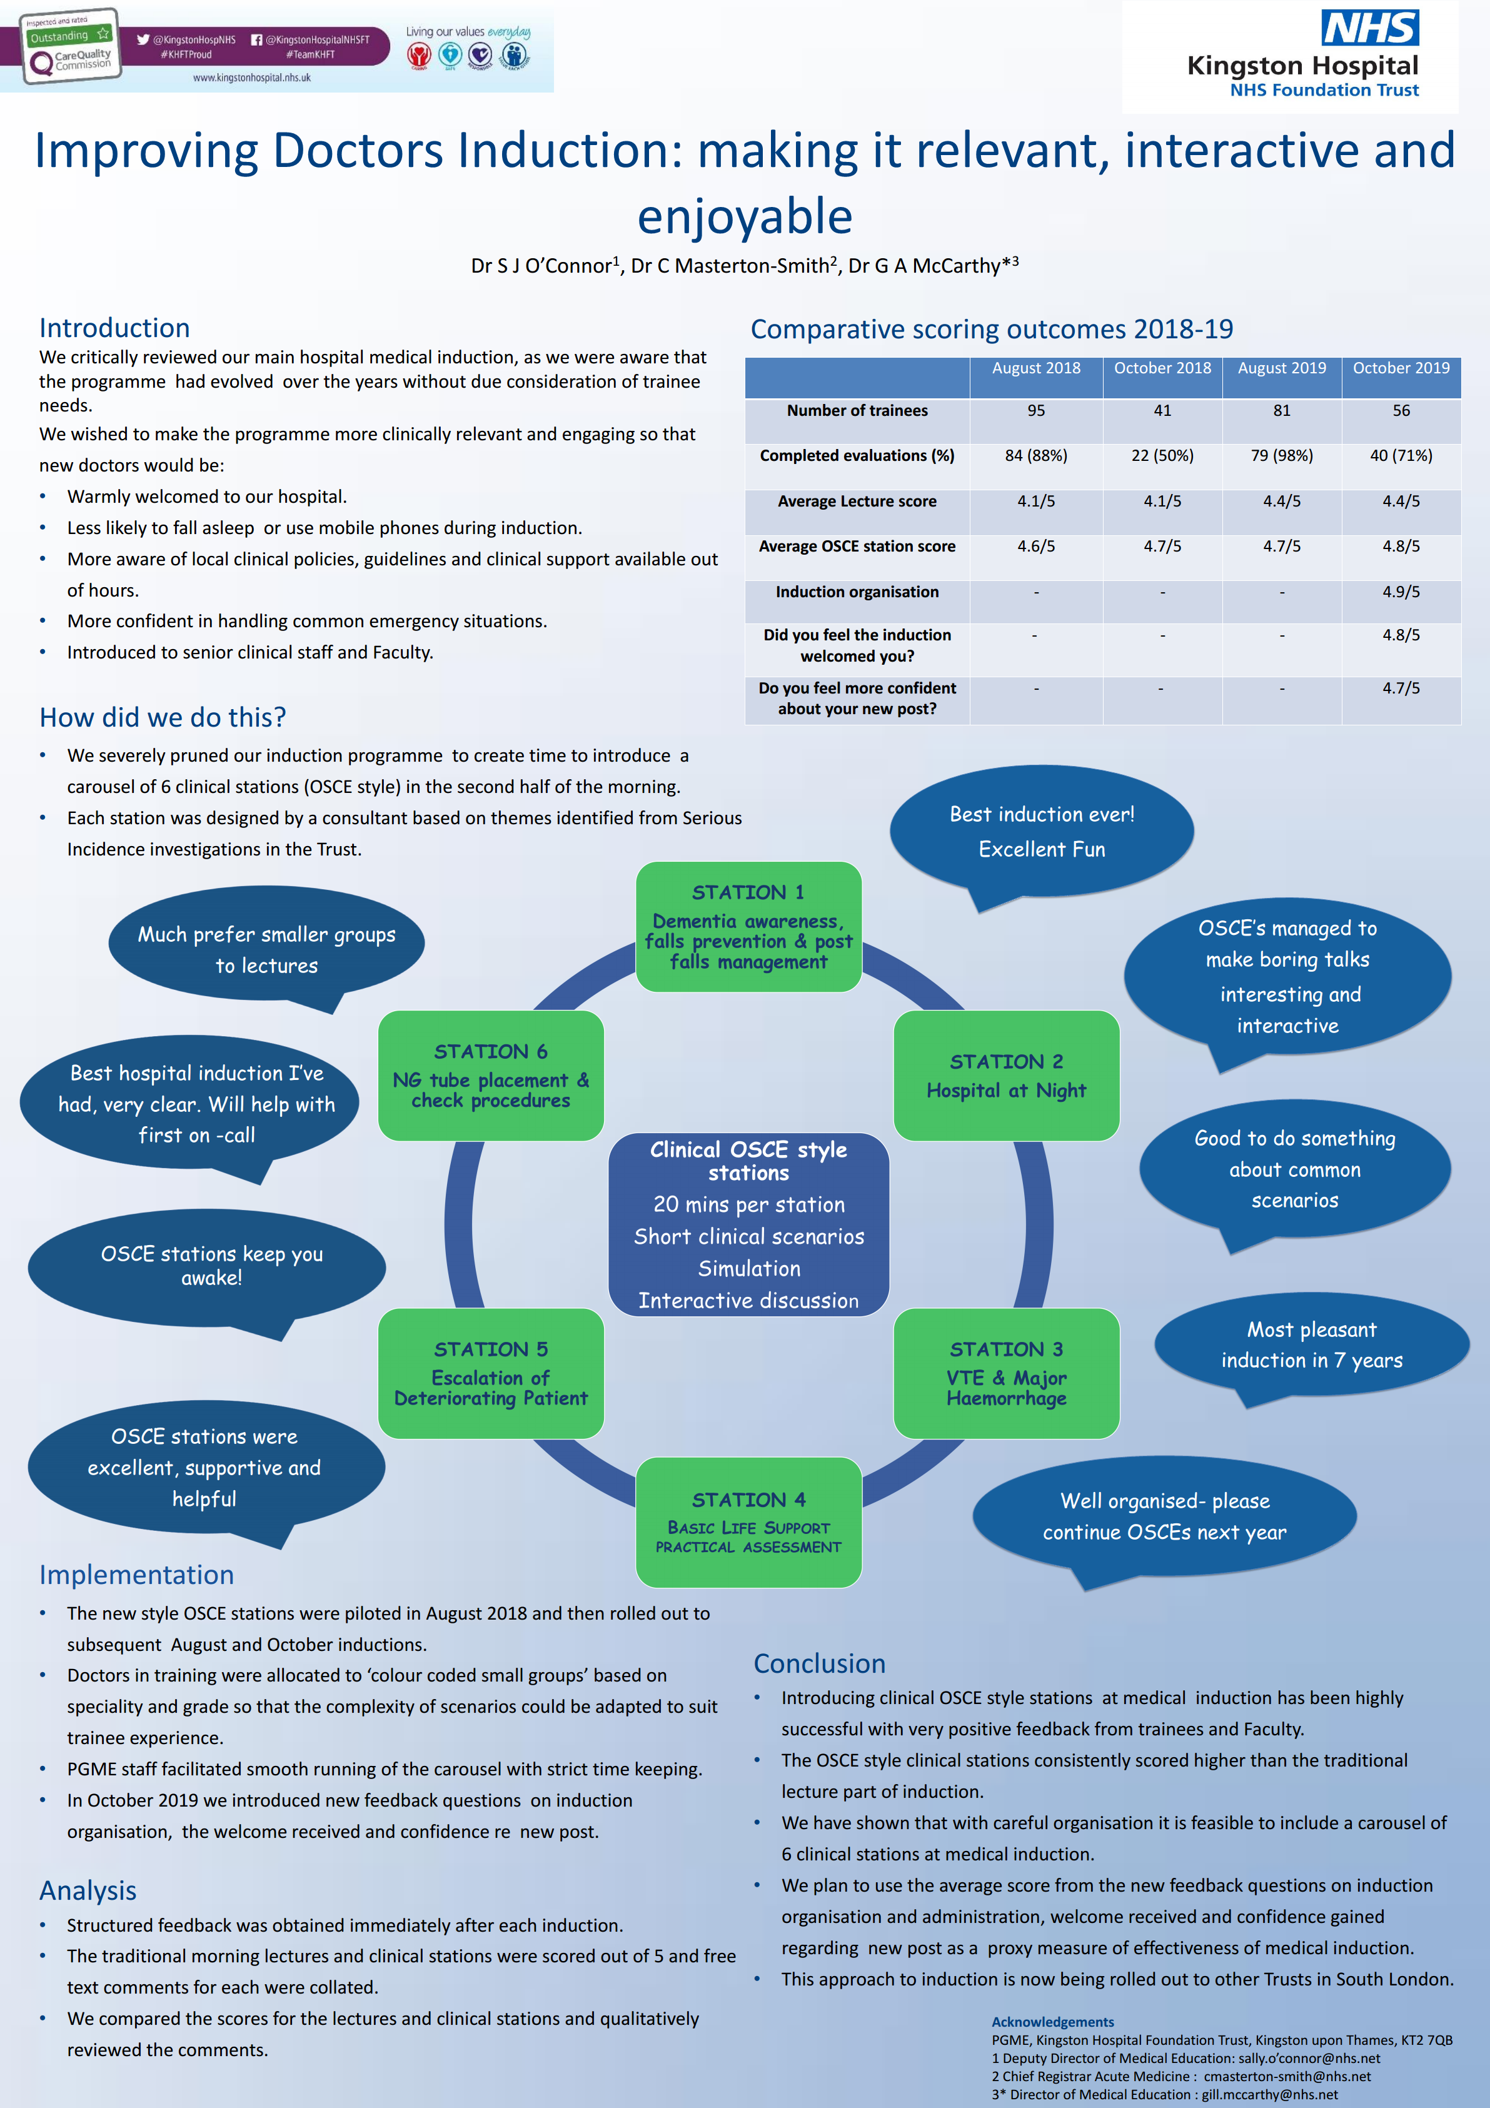

Note that Wales was not included in the sample as research relating to inductions in Wales had recently been conducted internally by the GMC.
Is a training requirement determined by the organisation and stipulated as a minimum requirement without which the individual would be unable to carry out the full range of their duties, and is, therefore, compulsory. Mandatory training (which incorporates statutory training requirements) is concerned with minimising risk, providing assurance against policies, and ensuring the organisation meets external standards.
Recommendation 5: The GMC should work with healthcare service providers, national bodies and representatives of overseas doctors to develop a suite of support for doctors new to UK practice. This should include information about cultural and social issues, the structures of the NHS, contracts and organisation of training, induction, appraisal and revalidation, professional development plans and mentoring. (page 28)
https://www.gmc-uk.org/-/media/documents/fair-to-refer-report_pdf-79011677.pdf
https://www.gmc-uk.org/about/how-we-work/corporate-strategy-plans-and-impact/supporting-a-profession-under-pressure/uk-wide-review-of-doctors-and-medical-students-wellbeing
Qualitative research is not intended to be statistically reliable and, as such, does not permit conclusions to be drawn about the extent to which something is true for the wider population.
https://www.bfwh.nhs.uk/onehr/wp-content/uploads/2019/08/ATSP-Booklet-2019.pdf
A workaround is a method for overcoming a problem or limitation in a program or system.
https://www.gmc-uk.org/-/media/documents/independent-review-of-gross-negligence-manslaughter-and-culpable-homicide---final-report_pd-78716610.pdf
Categories taken from ISM tool https://www.gov.scot/publications/influencing-behaviours-technical-guide-ism-tool/
The start date for new junior doctors is referred to as “Black Wednesday,” coined after a 2009 study (by Dr Foster Unit and Imperial College in London) showed that patients admitted to hospital in the first week in August had a 6-8% higher mortality rate than those admitted in the last week of July
https://www.bmj.com/bawa-garba
Categories taken from ISM tool https://www.gov.scot/publications/influencing-behaviours-technical-guide-ism-tool/
https://www.behaviouralinsights.co.uk/wp-content/uploads/2015/07/BIT-Publication-EAST_FA_WEB.pdf
https://www.gmc-uk.org/about/what-we-do-and-why/data-and-research/research-and-insight-archive/adapting-coping-compromising-research-exploring-the-tactics-and-decisions-doctors-are-applying

