GMC Connect user guide
GMC Connect is our system for managing the secure transfer of data, into and out of the organisation.
There are many occasions where we need to share digital information with the organisations and individuals who we work with. We are committed to the security of information – both ours and yours.
We use GMC Connect to share information with different external groups, such as:
- GMC associates
- responsible officers
- education organisations like royal colleges and faculties
- legal organisations
- other external stakeholders.

Accessing GMC Connect

Registering for a GMC Connect account
To access GMC Connect, you need to complete an online registration form that we’ll email to you. You must enter contact information about yourself, and your organisation if you represent one.
If you haven’t received our email, please check your spam folder or speak to your contact at the GMC.
Once you’ve submitted the form, we’ll review the details you provided within five working days. Assuming everything is correct, we’ll set up your account and email you a temporary password and a link to log in to GMC Connect.

Logging in

On the login page, enter your password and email address (the one you gave on your registration form).

Can’t access GMC Connect?

Please make sure you are using the correct link to log into GMC Connect [change link to: https://www.gmc-uk.org/connect]. You can access GMC Connect from the footer of any page across the GMC website.

Email address

I tried logging into GMC Connect but when I add my email address it says it already exists.
It is likely you have already provided us with your email address when logging in to GMC Online. Sign-in using your email address and password and you will be prompted to link your GMC Connect account.

My internet crashed while I was setting up a new user. I have tried to create a new user again but it won’t accept my email address.

Use the 'I can already sign in with my email address' link to sign in with your email and continue with the signing up process.

Password

I've clicked Forgotten Password and it says "We are having difficulty retrieving your information"
This usually means we can’t send you a One Time Password by email so we can authenticate your account. Please call our contact centre to check your contact details are up to date.

I'm trying to set up my new login and use my old password, but it says it's not acceptable.
Our new login service is more secure so your password must be between eight and 16 characters long. It needs to have at least three of the following four: capital letter(s), lower case letter(s), number(s), symbol(s).

Where can I change my password?
Click into the profile area in the top right corner of our website once you’re logged in and go to “Account Settings”. You can change your password from there.

My internet used to remember my password for me but now it doesn’t.
Your internet won’t “remember” your details because our log in page has moved. Your browser should remember your new details after you’ve logged in for the first time. If it doesn’t, you should check your internet settings.
If you’ve forgotten your password, click the “Forgot password” link.

I haven’t received the One Time Passcode (OTP) email, what should I do?
Our OTP email may take a minute or two to arrive. They are addressed from noreply@gmc-uk.org. Please check your junk email folder or any other folder your emails are diverted to if it doesn’t arrive. If you still can’t find the email please call us to check we have the correct email address for you.

I have received my One Time Passcode (OTP) but I closed my internet. How do I enter it?
If you didn’t complete the OTP process, simply start the process again. Your original OTP will expire after 20 minutes, but you can request a new one if required.

I'm trying to sign up, but when I enter the One Time Password (OTP) it tells me I already have an account.
Try to log in again, but on the sign-up form click ‘I can already sign in with my email address’. Enter your email address and password on the next page. You can choose to reset your password if you have forgotten it.

I want to use a different email addresses for correspondence and logging into my GMC Connect account. Can I do that?
Yes, your correspondence email address and login email address can be different or the same. If you would like to update your email addresses, please get in touch with your contact at the GMC.

Login error messages

There is not enough space on the disk
This means there is an issue with your account. Please get in touch with your GMC Connect administrator and they will be able to guide you further.

520 Server error

This error message occurs when our server doesn’t respond. Please try logging in again to GMC Connect [need to update to GMC Connect login page: https://www.gmc-uk.org/connect]

Account expiry

If you can’t log in, your account may have expired. Please contact your GMC Connect administrator for support and we can reactivate your account.

Managing more than one user group
You may represent more than one user group or organisation, but you should only have one GMC Connect account and set of login details for all your user groups.

This is so you don’t have to remember separate login details for each group or organisation.

Get access to more than one user group
We have an Existing user form that lets you add more user groups to your account. If you think you need access to more than one account, please ask your GMC Connect administrator to send you the link to the Existing user form.

If you accidently create more than one account, please contact your GMC Connect administrator for support.

Document folders

Accessing documents

We use Document Folders to share documents. Access to individual folders will be provided by the GMC Connect administrators as required.

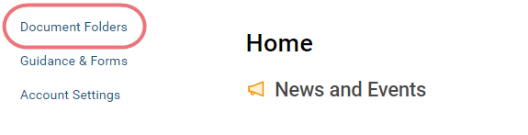
Listed in this screen are the document folders that we have shared with you.
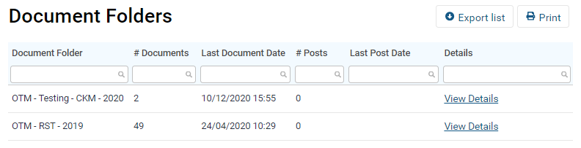

Downloading a document
To download a document, click on the link within the Document Folder.
The time it takes to download a file will depend on the size of the file and the speed of your internet connection.
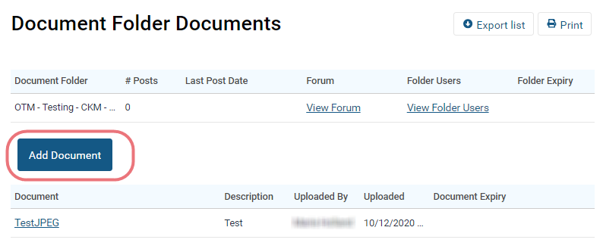

Uploading a document
To upload a document, click on the 'add document' button.
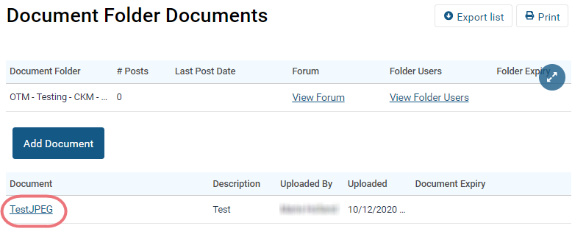
Click on the Choose file button to begin choosing a document. A window will appear prompting you to select a file to upload.
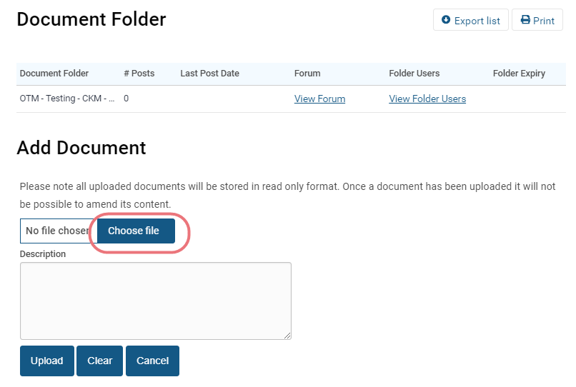
Select a file and enter a description of the file to be uploaded.
Click on Upload.
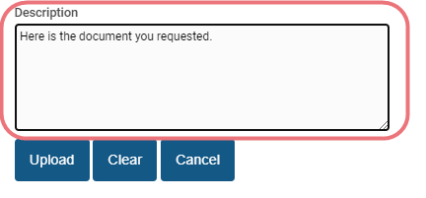

Once uploaded, your document will be shown in the Document Folder.
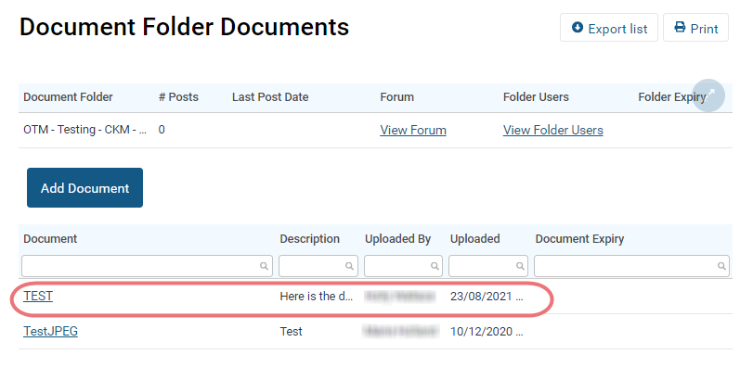

Adding a new version of a document
If you need to add an updated version of a document, you should upload this as a separate document, naming it appropriately, e.g. version 2.

Removing a document
Documents that have been uploaded to GMC Connect are locked down so they cannot be removed or modified. If you accidentally upload a file into the wrong folder, contact the GMC Connect administrator, who can move the file for you.

Having trouble with documents?

Accepted document types
The accepted files extensions that can be uploaded to GMC Connect are as follows:
.bmp,.csv,.dat,.doc,.docx,.dot,.dotx,.gif,.jpg,.msg,.mpp,.pdf,.pps,.ppt,.pptx,.rar,.rtf, .txt,.zip,.mp3,.mp4,.wav,.fdf,.xls,.xlsx
If the file type is not listed here, it cannot be uploaded to GMC Connect.

Correct file type
We will not be able to open files that have, for example, two file types file.xlsx.exe
In this case, please save the file as a standard excel file .xls rather than .xlsx and without the .exe file extension.

Acceptable document size:
There is a limit on the file size for uploading documents to GMC Connect and the maximum is 100MB.
The larger the file the longer it take to upload depending on the speed of your internet connection.

Zip files
You’ll will not be able to open Zip files in GMC Connect on an iPad, please use another device such as a laptop or tablet, if you need to open a Zip file.

Folder forum
The forum function allows you to post comments against a document folder. Note that comments that are posted are visible to all users who have access to the folder, including internal users at the GMC.
To view the comments held within a Document Folder, click on View Forum.
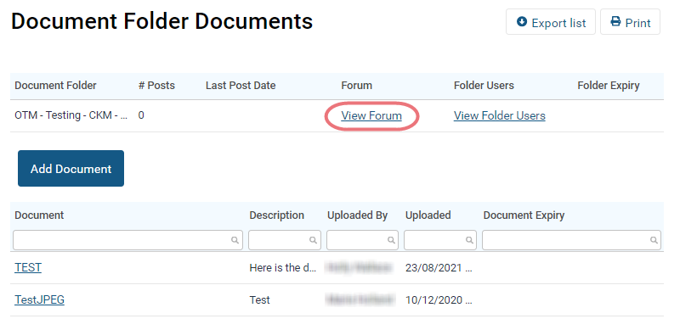

Guidance and forms
This section is gives you access to GMC literature and document templates.
Please note, you can’t upload documents into these folders.
